# Chanter I

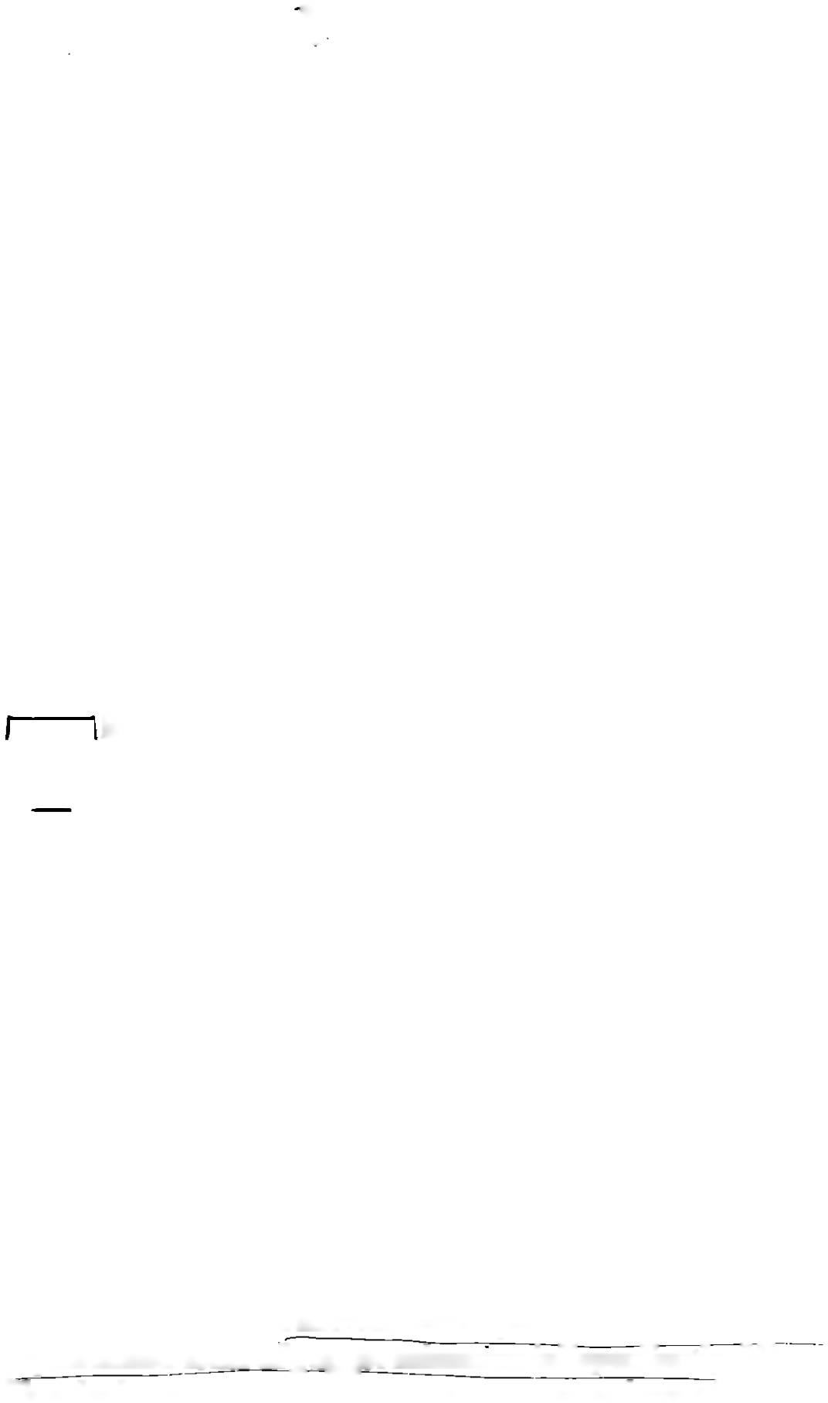

From Propaganda to' Children’s Films:

The Earliest Beginnings and the Stalinist Era of Soviet Animation

1. Vladislav Starevich

(1882-1965) was

bom in Russia to a Polish family. His original Polish name was Wladyslaw Starewic2. He is also known as Ladislav Starewich.

1. Recently discovered puppet animation films made by the famous dancer Aleksandr Shiryaev predates Starevich’s works, but these films were not produced for the public. See Beumers et al.

eds., *Aleksandr*

*Shiryaev.*

1. See Starevich’s first films: *Lucanus Census,* 1910; *The*

*Beautiful Liukanida, or the Battle Between Stag Beetles and Long-horn Beetles (Prekrasnaia Liukanida, Hi voina rogachei i usachei,* 1910).

1. Bendazzi, *Cartoons,*

40.

## Insects in motion:

**the first Russian animated films**

he very first animated films in Russia were the last vestiges of a pre-Revolutionary world, an isolated episode that began in 1910 and ended outside of the

Soviet Union, when their director, Vladislav Starevich,1 emigrated to France.2 Initially, his peculiar characters - dead insects - were moved by wires,3 but soon this gave way to plasticine models animated by stop-motion. This tech­ nique, which consists of taking a series of pictures of objects that are moved in small increments for each frame, was already used in trick filr i sequences, but it was rarely em­ ployed for an entire film. In Great Britain, Arthur Melbourne Cooper employed the stop-motion technique as early as 1899 to animate matches in a short advertisement film *(Matches: An Appeal),* and used it again with toys in *Dreams of Toyland* (1908);4 while in America, the technique was adopted only a few years later, in the mid-1910s, by Willis O’Brien. But Starevich developed an expressive and sophisticated form of puppet animation independently. His lilms had mainly an entertainment purpose and were based on original stories, adaptations from literary works, and, most commonly, on fables. The films were quite successful among audiences that were not accustomed to seeing pup­ pets move onscreen, least of all insects. They were also appreciated by Tsar Nicholas II himself, who awarded a

**5**

SOVIET ANIMATION and the Thaw of the 1960s

prize to *The Grasshopper and the Ant (Strekoza i muravei,*

1911).5 Starevich produced most of his films independently

- including the well-known *The Cameraman's Revenge (Mest' kinooperatora,* 1911) - but he was still able to maintain his connection with the Russian cinema world of the 1910s. In 1911 he joined one of the biggest Russian cinema companies of this period, the Khanzhonkov studio, and the following year he started to employ for the live-action sequences of his films a young actor who would soon become the best- known Soviet cinema star of the silent era, Ivan Mozzhukhin.6 After the Revolution, Starevich left Russia and moved to Fontenay-sous-Bois, near Paris. Back home, the new, politically engaged Soviet directors began to criti­ cize his work and dismiss him as a “children’s entertainer without educational value”.7 A few years passed before other animated films were created in Soviet Russia, and still more years before three-dimensional animated films returned to the screen.

## Moving caricatures and propaganda posters: the beginning of Soviet drawn animation

It was drawn animation that instead developed in the fledg­ ling Soviet Union in the 1920s. The particular political and historical situation of Soviet Russia demanded a kind of animation that was mainly propagandistic, thus distinct from the generally entertaining cartoons that formed the mainstream of US animation. While American animation 5 had its roots in comic strips and vaudeville acts, most of the early Soviet animated films came out of political manifestos and satirical vignettes; they were primarily caricatures and propaganda works addressed to an adult audience.

The Revolution brought with it a fervid impetus to any art accessible to the masses. Posters, caricatures, and animation were all able to convey in simple, linear traits and easily understandable conventions a message that could reach the largely uneducated common people. These popular forms of art were geared to serve the new Socialist order, promot­ ing the construction of a new society, as well as clearly defining its enemies. The most famous posters of the period, the *Okna ROSTA* (The Russian Telegraph and Press Agency Windows), have many traits in common with the

Martin. *Ladislav Starewiich.* 15.

Mozzhukhin starred in *The Terrible Vengeance*

(S *trash na ia mest'.* 1912: an adaptation from GogoP's story), which has not been

preserved, and *The Night Before Christmas (Nodi' pered rozhdestvom,* 1913). Bendazzi.

*Cartoons,* 36; Martin. *Ladislav Stareivitch,* 15.

Bushkin.

uKadro-s"emka''.

21.

**6**

Chapter 1 From Propaganda to Children’s Films

first Soviet animated films. The *Okna ROSTA* team (some of the main artists being Vladimir Mayakovsky, Mikhail Cheremnykh, and Ivan Maliutin) was charged with trans­ lating agitational messages and daily news into eye-catching pictures and brief texts. Some of these pictures represented a specific situation; others formed a succession of framed images, giving the poster a narrative quality in a form similar to comic strips. In Russia, however, the same organization of text and images originates not so much in the comic strip, but in religiqusjcons and in the traditional_/M6ofe,' a popular form of art that presented information or stories through images and straightforward texts, often with wit and humor. A violation of the picture’s temporal unity through the depiction of the heroes in several places characterized *lubok* works much in the way that in Russian religious icons, stages in a saint’s life are represented in contiguous small frames.

8 For a discussion of Soviet cinema of this time as a didactic tool for illiterate people, see Youngblood, *Movies for the Masses,* and *Soviet*

*Cinema in the Silent Era,, 1918-1935;*

Lawton. 77ie *Red Screen;* Kcnez, *Cinema and Soviet Society;* Taylor and Christie, eds.. *The Film Factor)';* and Gosudarstvcnnoe izdatelswo, *Kineniatograf.*

The *Okna ROSTA* utilized similar formal principles with an intent that was neither religious nor entertaining, but strongly political. The spirit that permeated these posters, the linear traits of the drawings, much like caricatures, and the juxtaposition of pictures in frames in order to tell a contemporary story made these posters a prototype story­ board for the Soviet animated films of the 1920s. Soviet cartoons sought to give life to the static pictures of Revolu­ tionary graphics and thus to increase the expressiveness and, consequently, the accessibility of their message. Animation was regarded as a step forward in the search for new means of propaganda, since it successfully combined the immedi­ acy of caricatures and posters with the original Soviet idea of cinema as an educational tool for the illiterate.8

The animation of these years had a strong link not only with posters, but also with caricatures of t! te time, namely those by the famous Viktor Denisov (Deni), Dmitrii Moor, Boris Efimov, Mikhail Cheremnykh, and other masters of poster graphics, who often worked for *Okna ROSTA* as well as

satirical journals such as *Bezbozhnik* (later called *Bezbozhnik u stanka)* and *Krokodil.* Not only did the films reflect the style and themes of the caricaturists, but some of their drawings were themselves animated in what went by the name of “animated caricature” *(ozhivshaia karikatura),* such as the film *Political Revues (Politicheskie obozreniia,* Fig. 1.1), in which

**7**

SOVIET ANIMATION and the Thaw of the 1960s

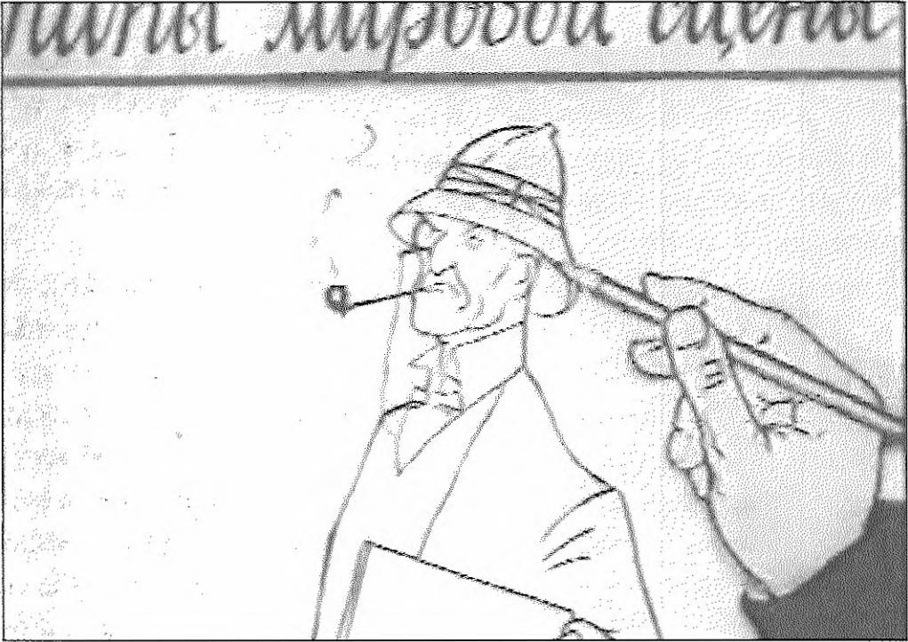

**Figure** *1.1. Animated caricatures. Still from* Political Revues.

Iurii Merkulov and Daniil Cherkes brought Deni’s carica­ tures to the screen.

Animated caricatures were a Soviet version of the filming of “lightning sketches” (also called “chalk talks”), vaudeville acts in which the artist would draw quick caricatures while performing a monologue. According to the early animation historian Donald Crafton, American animation stems from this form of popular stage performance - the first attempts to put these vaudeville acts on screen date back to the earliest American films, specifically James Stuart Blackton’s 77ie *Enchanted Drawing* (1900), and later, in a pure frame by frame animation, Hw/norows *Phases of Funny Faces* (1906).9 Despite early Soviet animation’s similarity to the “lightning sketches” technique and graphic caricatures, the Russian version was never meant to be mere entertainment, but had a specific political, ideological, and social goal.10

This purpose is already clear in the very first examples of drawn animated sequences that appeared on the Soviet screen, that is, the brief animated passages that Dziga Vertov introduced in his newsreel series *Kirto-Pravda (Film Truth,* issued by Goskino from 1922 to 1925). One of the earliest animated clips found in Soviet cinema is in fact a fragment that survived from a lost *Kino-Pravda* film called *Today (Segodnia,* 1923, Goskino [Kul'tkino]).This fragment, called *Live Map (Zhivaia karta),* depicts the international political situation of the time with the help of a map on which

Bendazzi, *Cartoons,*

8. For a comprehensive study of early animation, see Crafton. *Before Mickey,* and Crafton. *Emile Cohl, Caricature, and Film.*

Among those films that were preserved, see Merkulov’s *kinoplakaty* and political caricatures made in the 1920s (no precise date is known): *Our caricatures (Nashi karikatury). We Are With You, Cuba!*

*(My s toboi, Ku ba!). On the Material of Political Caricatures (Po materialam politicheskikh karikatur):* Merkulov's short made in 1927, *Our Answer to Chamberlain (Nash or vet Chemberlenu.* 1927); and Nikolai Khodataev’s films *Well Be Vigilant (Budem xorki,*

1927) and *The Menacing Vavila and Aunt Arina*

*(Groznyi Vavila i tetka Arina,* 1928).



1. Gessen, ‘‘Sovetskii

sharzh". 3.

1. *Aniiitatsiia of A do* M, dir. M.P. Liakhovctskii and

I.P. Margolina. RcnTV.j997.

countries’ borders are animated. Segments of animated sequences appeared not only in *Kino-Pravda,* but also in Vertov’s weekly newsreel series *Kinonedelia;* their themes ranged from depictions of army movements during World War I to animated leaflets promoting the fight against tuber­ culosis.

It was the same Vertov, in collaboration with the director Aleksandr Bushkin and animator Ivan Beliakov, who cre­ ated the first Soviet animated movie, *Soviet Toys (Sovetskie igrushki,* Dz. Vertov, 1924, Goskino [Kul’tkino]), a propa­ ganda film based on Deni’s drawings published in *Pravda.* The film provided a harsh critique of bourgeois behavior, from excesses in food and alcohol consumption to woman­ izing; it also satirized the Church and capitalists’ faith in redemption granted by corrupt priests. *Soviet Toys* hinted at specific contemporary matters, providing “solutions” to topical problems in a simple and straightforward way, such as the symbolic double figure of a worker-peasant, who fights a NEP (New Economic Policy) bourgeois and directs his money to the Bank of the People (“Narodnyi Bank”); and the film’s final image: a pyramid of Bolsheviks, with Red Army soldiers at its base, the peasant and the worker climb­ ing to the top, and all the representatives of the hated enemies hanging from it. It seems that the film was not widely publicized at the time; an article that appeared in the journal *Kinonedelia* in 1924 bemoaned the silence surround­ ing this film and the general lack of films depicting everyday Soviet life.11 Other articles published in 1924 lamented the scarcity of animated films released, and stressed the need to take full advantage of this new media. *Soviet Toys* has the quintessential elements of the ideal Soviet animated film of the time; it features topical issues, caricature style, simple traits, communist indoctrination, and, at the end, self­ advertising.

It was common practice for Soviet studios co advertise their own films. In the 1920s, most studios had a division dedi­ cated to advertising and frequently used animation not only to promote their own live-action films, but also to advertise commercial products,12 which constituted the lifeblood of the small private enterprises of the NEP era. The advertising business became an active branch in the cinema industry of the time; as Vertov comments in 1923, it was not only relevant but inevitable.

For five years there was no motion picture production in the Soviet Union. There’s none now. There is no money for it. Film advertising is the gateway to work, to production, to prosperity. We must make this “compromise”; we have to.lj

The quality of directness possessed by animation was indeed functional for both political films and commercial propa­ ganda.

In the meantime, Vertov still considered political animated films to be of extreme importance in these Revolutionary years, and collaborated with Bushkin and Beliakov on other films, such as *Humorous Stories (lumoreski,* 1924), a series of political cartoons concerning topical issues (only a few frames survived), and *Boris Savinkov: Story of a Disappointment (Boris Savinkov. Istoriia odnogo razocharovaniia,* 1924). But in reality it was Bushkin who had a bigger role than Vertov in early Soviet animation. Bushkin founded an animation stu­ dio at Goskino (Kul’tkino) in 1922,14 and gave an account of his experiments in animation in a couple of publications: *Frame Shooting (Kadro-s"emka,* 1926), and a longer publica­ tion, *Trick and Animation (Triuk i mul'tiplikatsiia,* 1926), which explained the use and the goal of animation technology at that time. Bushkin’s films exemplify the function of anima­ tion in these early years. They are all propaganda works that deal with political and social themes: the film ITTio *Dreams of What (Komu chto snitsia,* 1924) endorsed anti-religious propaganda; *In the Snout of the Second International (V mordu Vtoromu Internatsionalu,* 1924, of which only a fragment sur­ vives) presented in a schematic way international relations before World War I, and attacked the socialist grouping of the Second International, who betrayed the socialist cause by joining their respective ruling classes at the beginning of World War I; *What the 13th Party Congress Said About Coop­*

*eratives (Chto skazal XIII s"ezd partii o kooperatsii,* attributed to 13

A. Bushkin and A. Ivanov, 1924) promoted the organization *of* peasant labor into cooperatives; *Dem'ian’s Fuddle (Durman Dem'iana,* A. Bushkin, 1925) attacked alcoholism and en­ couraged attendance at Party clubs; and *MacDonald's Career (Kar'era Makdonal'da,* A. Bushkin, 1925, never released) was an attack on international politics, showing MacDonald, the leader of the English Laborites, as a puppet in the hands of capitalists.15

Propaganda films, political satires, and films based on cari­ catures and political pamphlets characterized most of the

Venov, *Kino-eye.*

31.

For an account of Bushkin’s works, see Elizarov, *Sovetskaia mul'iiplikaLdia,* 137.

Fragments of Bushkin's films had been shown in the documentary

*series Animaisiia ot A do IA,* dir.

Liakhovecskii and Margolina.



1. The studio Mezhrabpom. which subsumed Rus' in 1924. was financed by International Arbeitershilfe (International Worker’s Relief), a socialist organiza­ tion created in Germany in 1921. whose task was to aid Soviet Russia during the famine time. After the initial emergency the fund was destined to help the nascent Soviet cinema, in particular providing the necessary equipment and film from abroad,

and also facilitating

circulation of Soviet films in Germany and later in the rest of Europe.

Youngblood, *Movies for the Masses,* 14: Kenez. *Cinema and Soviet Society,* 38-39.

1. For an account of the activity of all early animators mentioned here, see Elizarov, *Sovetsk aid mul'tiplikatsiia.* For a description of the films’ content see Machcret and

Glagoleva. *Sovetskie khudozliestvennye ftl'my.*

1. Elizarov. *Sovetskaia*

*murtiplikatsiia.* 168; Ginzburg.

*Risovannyi i kukol'nyi fd'm,* 81.

production of Soviet animation during these early years. The most significant personalities in Soviet animation came out of the prestigious institute VKhUTEMAS (Vysshie Khudozhestvenno-Tekhnicheskie Masterskie - High Art and Technical Studios), namely Zenon Komissarenko, Iurii Merkulov, Nikolai Khodataev, Daniil Cherkes, and later Ivan Ivanov-Vano, the sisters Valentina and Zinaida Brum- berg, Ol'ga Khodataeva (sister of Nikolai), and Vladimir Suteev. All of them gathered at the new animation workshop at the studio “Mezhrabpom-Rus1”16 with the task of creating advertising and agitation reels.

In the titles of the first films made by the group formed by Komissarenko, Merkulov, and Khodataev, one can already sense the political agenda of the artists and their ideological and propagandistic approach: *Interplanetary Revolution (Mezhplanetnaia revoliutsiia, Z.* Komisarenko, Iu. Merkulov, N. Khodataev, 1924), *China in Flames* (Kitai v ogne, Z. Komisarenko, Iu. Merkulov, N. Khodataev, 1925), andHoiy *Avdotia Became Literate (Kak Avdotia stalagramotnoi,* Z. Komis­ arenko, Iu. Merkulov, N. Khodataev, 1925), which was not preserved.17

*Interplanetary Revolution* is a political science fiction animated film showing how the Soviet power would conquer the entire universe. It is a parody of *Aelita* (1924), the famous film by Iakov Protazanov, in which Zenon Komissarenko made the animated sequences. *Interplanetary Revolution* was not released, but its creators did not lose their enthusiasm for animation, and after a year they were already undertaking a second film, *China in Flames}3* Released in 1924, this was the first feature-length animated film made in the Soviet Union. It allegorically depicts the history of the repression of the poor Chinese population by capitalists and colonizers, and the birth of a national movement of liberation supported by the young Soviet rule. Stylistically, the film lacked unity, mainly because different episodes were assigned to three different artists, who did not have a homogeneous style. In every film created by this team, in fact, each episode bore the specific character of the artist who created it - Khodataev was more inclined towards realistic representation, Merku­ lov towards grotesque figures, and Komissarenko was closer in style to the caricatures of Moor and Cheremnykh. By the beginning of the 1930s, Komissarenko no longer worked on animation and had returned to drawing caricatures and

posters; not only most of his films, but also his drawings disappeared.19 Several films did not survive. Some were destroyed during the war or simply burnt - films were highly flammable and often caught fire - and some were just not preserved often enough; it was not a concern of the directors at that time to keep copies of their films, and no archives existed. Later, as was likely the case with Komis- sarenko, some films probably disappeared for political rea­ sons. The increasing production of films in the genre of political satire, pamphlet, and drawn animated posters *(ki- noplakaty)* can also be linked to the particular historical juncture. In 1921, Lenin launched the New Economic Pol­ icy (NEP) in order to recover from the difficult times of the Revolution and the Civil War, and to foster a rebirth of the Soviet economy by allowing a partial return to a market economy with small private enterprise. Though film pro­ duction and distribution had been nationalized, in this pe­ riod, private entrepreneurs, cooperatives, and associations financed many theatres.20 Audiences were reluctant to pay the high ticket prices (especially because of galloping infla­ tion) for the agit-films that had been the staple of production during the Civil War.21 The market orientation of this period of time led to a diversification of the repertory in live-action films, and in the mid-1920s most of the enter­ tainment-oriented films for the masses were imported from the West. In 1924, approximately 95 per cent of the films in distribution were foreign; most of these were German, but after 1924 American films were also very popular.22

The so-created cult of foreign films provoked a vivid dis­ cussion in the cinema world, the extreme consequence of which was the accusation of one of the main cinema studios,

Sovkino, during the Party Conference on Cinema Affairs on 15 March 1928, and its eventual closing in 1930.23 This

debate over foreign films sheds light on the 1927 film *One* 2o *Among Many (Odna iz mnogikh,* N. Khodataev, Fig. 1.2), which focuses on American cinema stars Mary Pickford and Douglas Fairbanks and also includes some live action foot- 21 age of Pickford and Fairbanks’s recent visit to the USSR. While offering a satire of the American cinema world, this 22 film also provides evidence of the success of American films during the 1920s. *One Among Many* had the twofold goal of attracting the contemporary public and, at the same time, 23 ridiculing their attitude towards foreign films, putting a

1. Elizarov, *Sovetskaia*

*mul'tiplikatsiia,* 168. There is also an issue *of* rhe documentary

*series Animatsiia ot A do LA* dedicated to Komissarenko.

Youngblood, *Moviesfor the Masses.* 14.

Youngblood. *Movies for the Masses,* 14.

Youngblood, *Movies for the Masses,* 15.

Youngblood. *Movies for the Masses,* 29.

Chapter 1 From Propaganda to Children’s Films

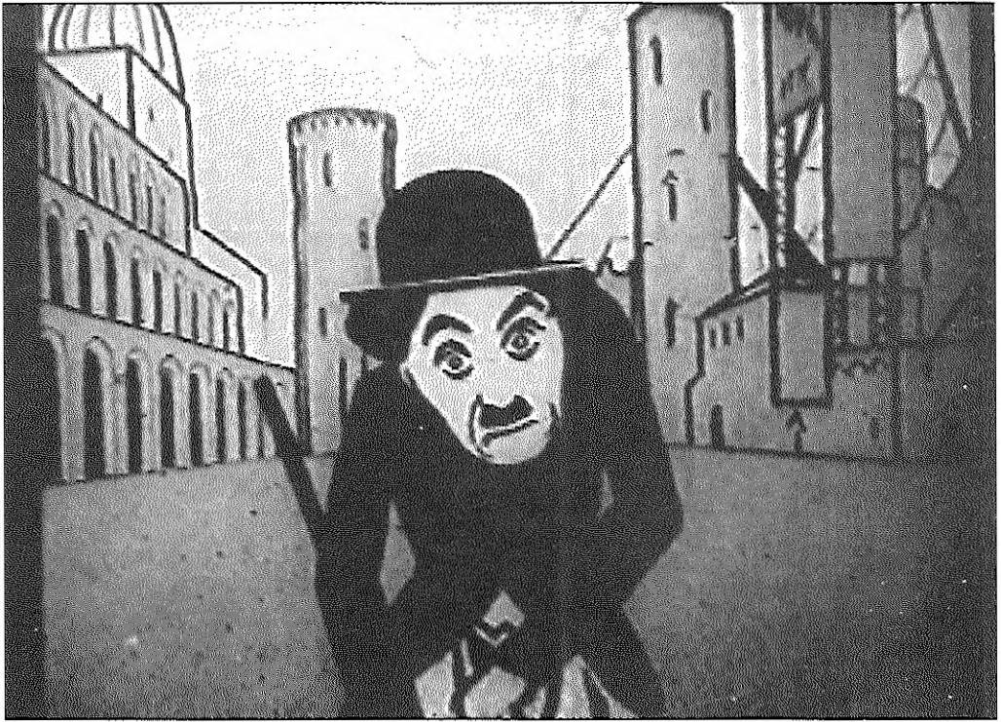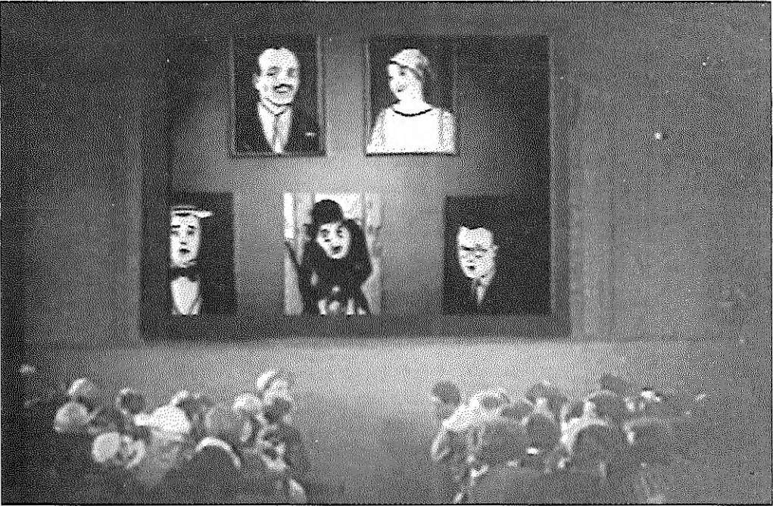

**Figure 1.2.** *Charlie Chaplin. Still from* One Among Many.

**Figure 1.3.** *Sequence of* One Among Many *in* The Kiss of Mary Pickford. *Still from* The Kiss of Mary Pickford.

particular emphasis on the supposedly capitalist, dictatorial world from which these foreign films originated. Inciden­ tally, sequences of this film were shown also in Sergei Komarov’s live-action film *The Kiss of Mary Pickford (Potselui Meri Pikford,* 1927, Fig. 1.3), creating an instance of film- within-film that accentuates the criticism of the American cinema world.

This change in orientation within live-action cinema might have pushed animation to take up the propagandistic role fulfilled until that point mainly by agitational films. Anima-

tion started to develop inside Soviet cinema studios already in 1923, and the number of animated films produced in the Soviet Union rose every year, from one in 1923 to 7 in 1924, 9 in 1925, 22 in 1927, and 24 in 1928.24 It seems that there is a break in production in 1926, in which only two films were made, maybe due to a fire that forced the animation division of one of the most productive studios, Mezhrab- pom-Rus', to look for another location.25

By the beginning of the 1930s, there were active sectors of animation in the Soviet cinema studios Mezhrabpomfil'm (closed in 1936), the Moscow and Leningrad studios of Sovkino (abolished in 1930 and replaced by Soiuzkino in 1935), Mosfil’m (founded in 1935), VUFKU (Ukraine), and Goskinprom Gruzii (Georgia). Some animation collec­ tives were also created at the studio in Erevan. The directors of these film studios *(kinofabriki)* usually supported the young animators, but left them free to choose themes and styles for their films.26 Thus, the animators were more independent and more prone to experimentation. In addi­ tion to animated features, animation was employed partially or totally in other sections of the studios, such as in the educational and scientific film divisions, which started to be quite active in the mid-1920s.

## Enlightening the masses: educational and 24

**scientific films**

The Soviet communist ideal of educating the masses was a stimulus to produce not only propaganda but also educa­ tional and scientific films. However, the first scientific films 25 in Russia were made not after the Revolution, but already

in Tsarist time, between 1911 and 1915. Nikolai Baklin, a physicist and a contributor to these films, recalls in his 26 writings how Khanzhonkov succeeded in establishing in his production company, Aktsionernoe Obshchestvo Khan­ zhonkov i K°, a division dedicated to educational and scien­ tific films, despite the general difficulty of obtaining funds 27 for such films. Some of the films featured only some ani­ mated scenes, but some others were entirely animated. Most of the purely educational and scientific films were hard to show; schools did not have projectors, and films could be screened only during organized lectures, which were quite rare since the Ministry of Education did not express any interest in them.27 The war put a halt to the production of

For details about the films, see Macheret and

Glagoleva, *Sovetskie*

*khudozhestvennye fd'my.*

The accident is mentioned by Ivanov-Vano in his *Kadrza kadrom.*

Ivanov-Vano, *Kadr za kadrom;* Sergei Ginzburg, *Risovannyi i kukol'nyifd'm.*

N.V. Baklin and

A.G. Kalashnikov, “Pervye shagi nauchnogo kino v Rossii”, 184; Baklin, “Vospominaniia o dorevoliutsionnom periode v kmematografri”, 171.



1. Ivanov-Vano, *Kadr*

*za kadrom,* 23-25.

1. The most relevant articles being: Bushkin,

“Kadro-s"emka”; and O. Kuz'ma, “Zadachi mul'tiplikatsii v kino”.

1. Kuz 'ma, “Zadachi mul'tiplikatsii v kino”, 56-60.
2. Kuz'ma, “Zadachi mul'tiplikatsii v kino”, 56-60.

the Khanzhonkov studio section, and films of this kind did not appear again until a few years after the Revolution. Some films were made at Kul’tkino, a division of Goskino (which in 1925 became Sovkino) where Baklin worked, others in the studio Mezhrabpom-Rus', where, in the 1920s, the now-famous director Ivanov-Vano began xhis career as an animator. Ivanov-Vano briefly recalls in *Frame by Frame* his first works at the studio in the 1920s: an educational film that explained bottle making, *Glass and China Industry (Stekol'no-faiforovaiapromyshlennost',* date unknown); and ani­ mated sequences of a more detailed scientific film, *Mechanics of the Brain (Mekhanika golovnogo mozga,* 1926), made by the renowned live-action director Vsevolod Pudovkin.28

A few articles published in the mid-1920s29 stressed the importance of educational and scientific films in the new Soviet society. Among them, an article that appeared in 1925 in one of the leading cinema journals, *Sovetskoe kino,* pro­ vided a lengthy list of the goals of animation in the Soviet Union.30 This list is worth mentioning since it gives a glimpse of the ambitions and concerns of directors and cinema personalities alike. According to the author O. Kuz'ma, animation should deal with an extraordinary variety of issues, from the eradication of illiteracy to the teaching of productive land tenure; it should illustrate social and health problems (such as tuberculosis, syphilis, alcoholism) and provide elementary notions of geography, ethnography, natural science, technology, economics, and politics. Films should also address various contemporary topics, such as plans of electrification in Soviet Russia, introduction of cooperatives in villages, communist education, history of the Revolutionary movement, the Soviet regime’s undertak­ ings, the role of farming and industry in the country, and the place of the Soviet Union among bourgeois countries.31 Animation was designated as the privileged media for ren­ dering all these themes accessible to the masses. Regrettably, only a small amount of animated films actually came into being.

## Entertaining and educating: the first animated films for children

If most of the first Soviet drawn animated films were, tar­ geted to an adult public, towards the end of the 1920s films

**Figure 1.4.** *Thin white profile on black background.*

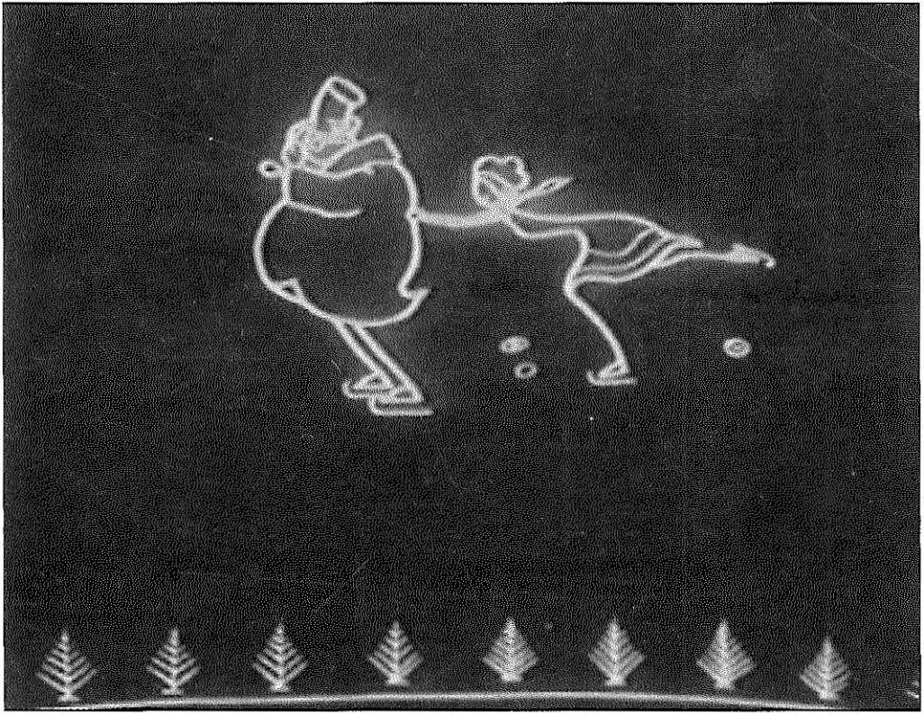

*Still from* The Skating Rink.

for children also made their appearance. Educating the new generation was increasingly important, and animators felt the need to take advantage of the accessibility of animation to address the young public.

The first animated films for children were made in 1927, a year that saw more than one youth-oriented production. Only two of the films released in this year have been pre­ served:32 *Sen'ka the African (Sen'ka Afrikanets,* Cherkes, Merkulov, Ivanov-Vano, 1927), based on the story *Krokodil* by the famous children’s writer Kornei Chukovskii; and the film *The Skating Rink (Katok,* Ivanov-Vano, Cherkes, 1927, Fig. 1.4), whose graphic choice — a thin, white profile on a black background - is unmistakably indebted to the work of one of the world’s first animators, Emile Cole. Both films used successful comic gags and a laconic but highly expres­ sive style.

At the end of the 1920s, new artists focused on animation for children. In 1928, four talented artists, Nikolai and Ol’ga Khodataev and the sisters Valentina and Zinaida Brumberg, gathered together at the Moscow Tret'ia Fabrika Sovkino to produce one of the most successful animated films of these early years, *The Samoed Boy (Samoedskii mal'chik,* 1928), the story of a boy who grows up in a cold countryside, rebels against his people’s superstitions, leaves the country to study

Films for children were created in 1927 in more than one studio: in Ukraine, Viacheslav Levandovskii’s *The Tale of the Straw Bull-Calf (Skazka o*

*solomennom bychke);* in Leningrad at Sovkino,

*Vi ntik-Shpin tik* (Vladislav Tvardovskii); in Moscow at Mezhrabpomfil'm, *Moidodyr* (Maria Benderskaia, puppet film); and at Moskovskaia fabrika Sovkino,

*The Huge Cockroach (Tarakanishche,* Aleksandr Ivanov). However, none of these films

survived- For details about these films, see Macheret and

Glagoleva, *Sovetskit khudozhestvennye ftl'my.*

1. Ginzburg. *Risovannyi i kukol'nyijil'm;* Elizarov. *Sovetskaia imd'iiplikaLsiia;* Macheret and Glagoleva, *Sovetskie kh udozhestven nye fil'my.*
2. Another animated film in which Lunacharskii appears in person is *Tip-Top in Moscow (Tip-Top v Moskue, A.* Ivanov, 1928). Macheret and Glagoleva, *Sovetskie khudozltestven nye*

*fd'tny,* also in Ivanov-Vano. *Mul'riplikatsiia*

in the city, but still longs for his village and the nature that surrounds it. This film conveys an ambivalent message: the diverse features of such an immense country as the Soviet Union are glorified in the film, but at the same time “diver­ sity” is controlled and channeled into state institutions. *The Samoed Boy* is particularly significant for its technical achievements in conveying the characters’ movement; the scene of the sledge ride helped many animators in rendering the movements of animals on the run. While Nikolai Kho- dataev was already famous, his sister Ol'ga and Valentina and Zinaida Brumberg had started to work as directors only a year earlier and went on to become some of the most prolific animation directors of the years that followed?3

At the same time, at Sovkino in Leningrad, Aleksandr Pres­ niakov and Igor’ Sorokhtin, working with the artist Vladislav Tvardovskii, made a film called *The Offended Letters (Obizhennye bukvy,* 1928). The film’s plot is simple: the letters of the alphabet revolt in protest against schoolboys’ negligence; some delegates among them are sent to Nark- ompros (Narodnyi komissariat prosveshcheniia - The Peo­ ple’s Commissariat of Enlightenment) with a complaint about the children. Had this film been preserved, it would constitute a historical document, since in it animation was combined with live-action sequences and the animated delegates to Narkompros were received by no less than the Commissar of Enlightenment, Anatolii Lunacharskii, in person.34

A particularly successful film for children was *The Adventures of Munchausen (Pokhozhdeniia Miunkhauzena),* an adaptation of Rudolf Erich Raspe’s tales, produced in 1929 by D. Cherkes, I. Ivanov-Vano, and V. Suteev. The film’s style, which recalls Gustave Dore’s characters, pleased both chil­ dren and adults, the latter especially impressed by R.E. Raspe’s subtle irony.35

Towards the end of the 1920s, serial characters made their first appearance in Soviet cartoons. American cinema cer­ tainly influenced this trend, from the live-action star system with personalities such as Charlie Chaplin, Mary Pickford,

*vchera isegodnia,* 19. and Douglas Fairbanks, to cartoon characters such as Felix

1. *Aiiimatsiia ot A do IA,* dir. Liakhovetsldi and Margolina.

the Cat, Oswald the Lucky Rabbit, and Mickey Mouse. Even earlier cartoon characters seem to have influenced Soviet directors, especially Koko the Clown from Max Fleischer’s

series *Out of the Inkwell,* which was shown in Moscow in 1924 and which, as the director Khodataev mentions in his writings, inspired the Russian serial character Tip-Top.36 There were two advantages to having serial characters: first, it would attract audiences willing to follow their adventures from film to film; second, it would save time and work by using some of the drawings for more than one cartoon. The drawn characters Tip-Top, Buzilka, Murzilka, and later Kliaksa appeared in some films, but the most prolific char­ acter was the puppet Bratishkin. Most of these films attempted to be entertaining while conveying a political or social message. They combined live-action footage and animation in the hope of attracting a broader audience of both adult and young spectators. However, none of these characters survived for long, mainly because animation at the end of the 1930s turned to new themes and styles.

## Waiting for cel animation: drawings and flat marionettes

The type of animated films produced in the 1920s and early 1930s was strictly connected to the techniques available in Soviet Russia at that time. Soviet animators used simple outlines like those in caricatures to accelerate production, but an extraordinary amount of work was still necessary to draw frame by frame every single character’s movement and the corresponding background. Russian artists waited longer than Western animators for the arrival of the ad­ vanced cel technique, that is, drawing on transparent sheets of celluloid. This delay was perhaps due to the cost of cels or to the European tradition of puppet theatre, which, as Donald Crafton ventures, strongly influenced the choice in animation of flat marionettes and cut-outs.37 Most of the films made at the very beginning of Soviet animation were either realized through drawings on paper or through flat paper marionettes with movable joints. Cut-outs permitted animators to avoid the complete re-drawing of full figures and background and thereby accelerated the film-making process, but the movement created by adjusting, frame by frame, parts of these paper marionettes was definitely less smooth than the fluid movement achieved with the draw­ ings. However, the brusque and jerky gestures so obtained had a mechanical character well suited to the grotesque traits of the individuals represented in the satirical and propagan-

1. Khodataev, “Iskusstvo mul'tiplikatsii”, 88.
2. Crafton, *Before*

*Miekey,* 257.



distic films. Yet, flat marionettes allowed only a very limited range of movements and forced a depiction of the characters mostly in profile. In order to obtain greater flexibility, flat marionettes were replaced by paper cut-outs with autono­ mous body parts (such as hands, legs, head, etc.) that the animators could adjust or substitute after each take. The various phases of the characters in movement were cut out from a sheet of paper, so that the environment depicted underneath would be visible at any time around the charac­ ter in motion; hence, the background did not need to be re-drawn for each frame. Still, the background was simple and characterized by a few fundamental elements in order to allow a harmonious combination of characters and sur­ roundings.

Only with the introduction of the cel technique and the possibility of tracing the various phases of a character’s movements on transparent sheets could animation develop more complicated forms with more attention to detail; but in Russia, celluloid sheets came to be available only in the mid-1950s. The new technique brought a series of conse­ quences that influenced the entire Soviet animation system, from production to stylistic choices.

## Puppet and stop-motion animation

At the same time as cut-outs and flat marionettes, puppet animation also developed in the early years of Soviet anima­ tion. Various personalities distinguished themselves in this field. Among them it is worth mentioning Iurii Zheliabuzh­ skii, Viacheslav Levandovskii, and especially Aleksandr Ptushko. Zheliabuzhskii was already famous for some of his agitation shorts *(agitki)* and some live-action films, such as *The Cigarette Girl from Moscow (Papirosnitsa ot Mossel'proma,* 1924) and *The Collegiate Registrar* (or *The Station Master, Kollezhskii registrator,* 1925); as well as for his camerawork for such well-known films as Protazanov’s *Aelita* (1924). Zheliabuzhskii first tried animation in 1927, collaborating with Cherkes and Ivanov-Vano on *The Skating Rink,* but his major contribution to animation was *The Adventures of Bolvashka (Prikliucheniia Bolvashki,* 1927), in which live- action footage is combined with stop-motion animation using a wooden marionette, Bolvashka, reminiscent of Pinocchio and his Russian version Buratino, as well as of the

traditional Russian puppet Petrushka. *The Adventures of Bolvashka* was Zheliabuzhskii’s second and last animated film;38 soon thereafter he had to leave his work in cinema­ tography, presumably for political reasons.39

During the mid-1950s, some puppet films were also pro­ duced in the studio Mosfil’m by the director Viacheslav Levandovskii, who had previously worked in drawn anima­ tion at the Odessa studio VUFKU, where he created *The Tale of the Straiv Bull-Calf (Skazka o solomennom bychke,* 1927), the first Ukrainian animated film. Once Levandovskii

moved to Moscow, he turned to puppet animation with the 38 films *The Fox and the Grapes (Lisa i vinograd,* 1936), *Silver Rain (Serebrianyi dozhd',* 1937), and later *In the Land of Puppets* (K *kukol'noi strane,* 1940).40

But it was at another Moscow studio, Sovkino, where pup­ pet animation came to thrive thanks to the most famous

puppet animation director of this era, Aleksandr Ptushko. 40 Unlike his earlier colleagues who dealt with animated draw­ ings in a sometimes crude agitational way, Ptushko was able

to meet the high demand of these years for films concerning aspects of Soviet contemporary life, and in particular propa­ ganda topics, in an original and enjoyable way. In 1928 41 Ptushko began to produce animated films in which he combined live-action film with stop-motion technique. His early film, An *Event at the Stadium (Sluchai na stadione,* Tret’ia Fabrika Sovkino, 1928), introduced Bratishkin, one of the first serial characters in the history of Soviet animation.41 This film - the only one with Bratishkin that has been preserved - was based on a simple story that depicted Bra- tishkin’s disappointment at having missed a Spartiakiada soccer game. The film is particularly significant in the way

it engages in the broader artistic discourse on self-reflexivity and production. It exploits the characters’ adventures to showcase the work of the Sovkino cameramen; thus, it artfully promotes in a self-referential way one of the major Moscow studios, much in the way Vertov used self-adver- tising (although less subtly) in his *Soviet Toys.* While viewing *An Event at the Stadium,* Vertov comes to mind repeatedly - the way cameramen are depicted shooting from the most original places and the words used to praise them take us back to Vertov’s theories on the role of the camera as a privileged recording eye of reality and evoke his subsequent film *Man with a Movie Camera* (1929) (Fig. 1.5).

Macheret and Glagoleva, *Sovetskie kh udozhestven nye filmy.*

*Animatsiia ot A do LA,* dir.

Liakhovetskii and Margolina.

Elizarov, *Sovetskaia mul'tiplikatsiia;* Macheret and Glagoleva, *Sovetskie kh u dozhestven nye fl'my.*

Bratishkin would appear in some other Ptushko films, such as *One*

*Hundred Adventures (Sto prikliuchenii,* 1929) and *Let's Bring the Cinema to the Countryside! (Kino v derevniu!,*

1930) , as well as in

Merkulov’s drawn films *Night Alarm - Bratishkin In The Barrack (Nochnaia trevoga - Bratishkin v kazarme,* 1928) and *Adventures of Bratishkin (Prikliucheniia Bratishkina,* 1929). The last film made with Bratishkin

was Tvardovskii’s

*Bratishkin Competes (Bratishkin sorevnuetsia,* 1930). Macheret and Glagoleva, *Sovetskie khudozhestvennye ftl'my.*

**Figure 1.5.** *Cameramen in multiple-frame imagery.*

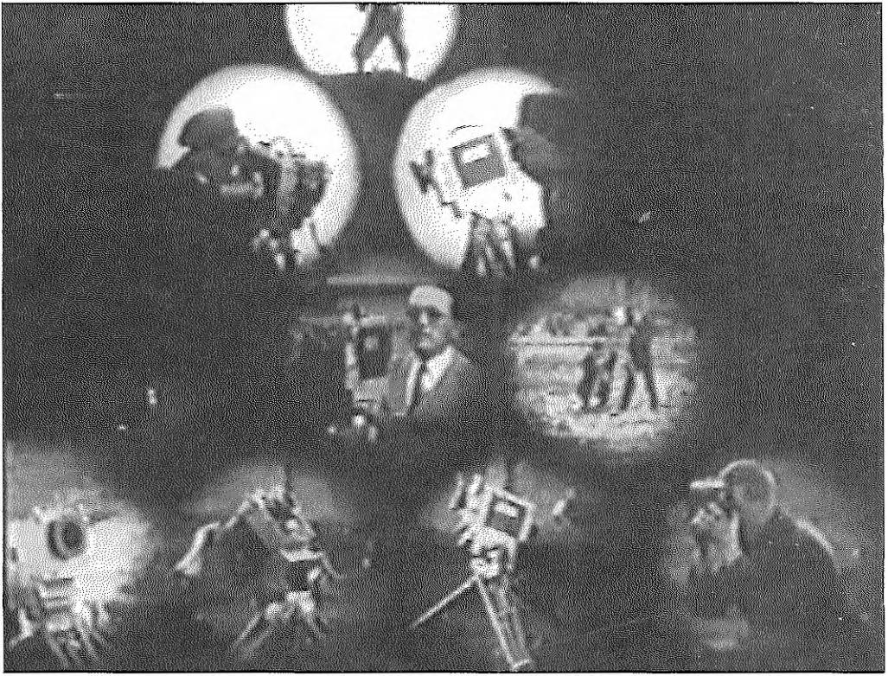

*Still from* An Event at the Stadium.

Another of Ptushko’s puppet films, *Master of Daily Life (Vlastelin byta,* A. Ptushko, Moskovskaia Fabrika Soiuzkino, 1932), addresses the new Soviet life on several levels: from a spatial level (the question of living places), to promotion of hygiene, to finally an implicit political message. The story presents a family that moves to a new house in an unsuc­ cessful attempt to get rid of the bugs that torment them. The Constructivist style of the new house is loaded with conno­ tations of a specific moment in Soviet art and architecture, while the efficient, clear, and defined traits of this style sharply contrast with the main characters’ way of living. The words that end the film: “Enough! We must be able to live in our new home!” (“Dovol'no! Nuzhno umet' zhit' v no- vom dome!”) echo as an exhortation to Soviet citizens in general to learn the rules of the new society and banish the old “parasites” (that is, the old bourgeoisie).

Ptushko’s most successful film was the feature film *The New Gulliver (Novyi Gulliver,* script by G. Roshal, Moskinokom- binat, 1935). In a clever and careful combination of live-action sequences and stop-motion photography of con­ ventional and grotesque puppets, Ptushko transformed Jonathan Swift’s story into a contemporary tale with very strong political content: after falling asleep on the book of Gulliver’s adventures, the Pioneer Petia dreams that he has

SOVIET ANIMATION and the Thaw of the 1960s

become a new Gulliver and will lead the poor Lilliputians in their revolution against the rich rulers of their country.

A successful combination of puppets and live-action se­ quences also characterized Ptushko’s last puppet animation film, *The Little Golden Key (Zolotoi kliuchik,* Mosfil’m, 1939), an adaptation from A. Tolstoy’s story about the adventures of Buratino. After this film, Ptushko turned his efforts towards live-action films, and only sporadically collaborated as an artistic director on some other animated films.

With the introduction of the cel technique in the mid-1950s and the simultaneous tendency to abandon every reference to actuality, two factors that I shall discuss later in this chapter, experimentation with puppet films slowed down and came to an end before the beginning of World War II. Only in 1952 was a division of the studio Soiuzmurtfil'm assigned to the production of puppet films. During its first two years, this division released only a few films, but the production of three-dimensional animated films soon in­ creased, and greatly developed starting in the late 1960s and 1970s.

## The Leningrad experience: book illustrations meet avant-garde works in Mikhail Tsekhanovskii’s films

While Soviet animators were producing a variety of films in Moscow, in Leningrad, the book illustrator Mikhail Tsekhanovskii (1889-1965) was experimenting with his drawings and trying to bring animation closer to avant-garde work. Like most Soviet directors, however, Tsekhanovskii never reached the modernist extreme of complete abstrac­ tion favored by several contemporary European directors. This was not only because abstract formalism was harshly attacked by Soviet officials, but also because Soviet artists at that time were more concerned with delivering a specific message to the audience.

Tsekhanovskii came to cinema only after working in the publishing world as a book illustrator, an experience that clearly marks his distinctive style. The new and influential school of graphics for children’s books founded by Vladimir Lebedev in Leningrad in the 1920s greatly influenced Tse­ khanovskii. Lebedev brought children’s book illustrations to a high artistic level; the book, in fact, was conceived as a

blend of literature and art and the artist’s name would appear on the cover together with the author’s name. Tsekhanovskii worked next to Lebedev at the children’s book publisher Raduga, and at Lengiz as an illustrator of books by well-known children’s writers such as Samuil Marshak and Kornei Chukovskii. His illustrations recall some peculiarities of Lebedev’s drawings, such as clarity, laconism, the use of the directness of poster style, elements of journal graphics, and advertising. Among the artists com­ ing from Lebedev’s school, Tsekhanovskii was the one who first linked book illustration to animation. His films deserve some closer analysis in this study, because they not only represent the most significant works of animation of these years, but also provide a model to which some directors of the 1960s referred.

Tsekhanovskii’s first film, *The Post (Pochta,* 1929), had its origins in his illustrations drawn for a popular text for children of the same title written by Samuil Marshak and published as an illustrated book in 1928. Marshak’s verses told a story about a letter which travels around the world, passing from postman to postman following the itinerant addressee Mr. Zhutkov. While animating his book, Tsekhanovskii wished to be faithful to the original traits of his drawings and opted for the same technique as his col­ leagues in Moscow: cut-outs.

The following year, 1930, Tsekhanovskii added Vladimir Deshevov’s music to the film, making of the sound version of *The Post* the first sound animated film in the history of Soviet animation. Unfortunately, the sound version of the film has been lost, and what has been preserved is only the original silent version. In 1964, however, Tsekhanovskii remade the film with a rearrangement of Deshevov’s origi­ nal musical score. For this version, Tsekhanovskii aban­ doned the cut-out figures of the original film and used the modern technique of drawings on cel. The result is, stylis­ tically, a completely different film that is hardly comparable with the 1930 version. Most of the films made by Tsekhanovskii from the 1940s onward lack that special indefinable quality that characterizes works of art. The me­ ticulous attention to characters’ movements, often repro­ duced with the help of a rotoscope (in Russian *elder),* deprives the film of the poetic imperfections and originality that distinguished Tsekhanovskii’s first films.

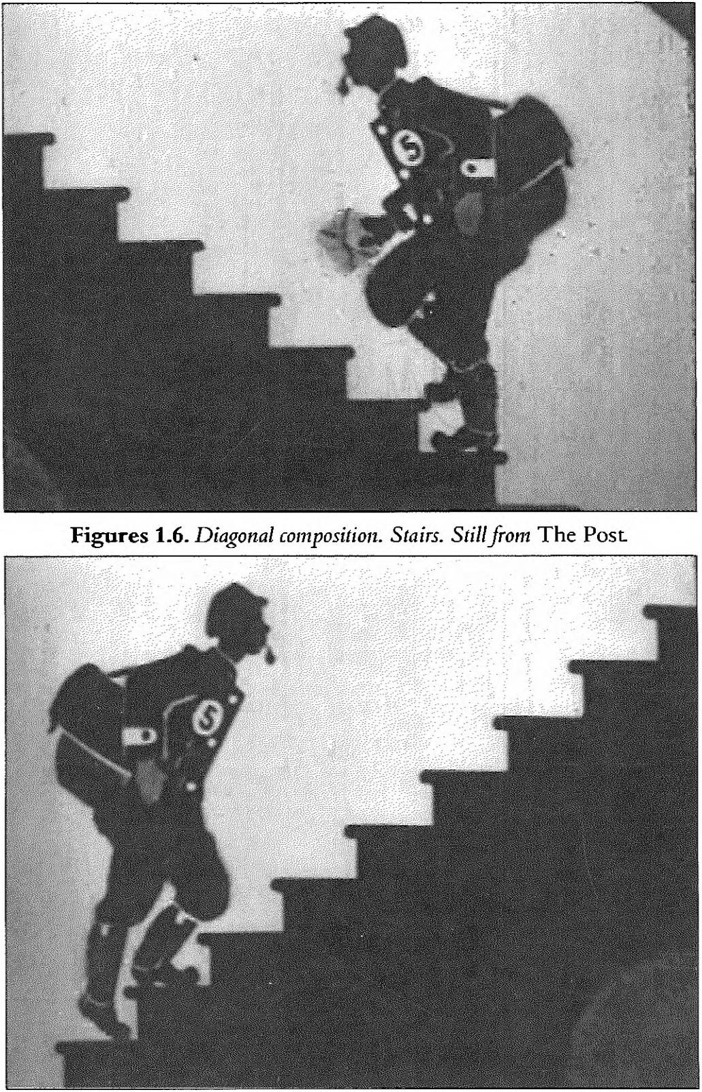

SOVIET ANIMATION and the Thaw of the 1960s

In 1994, the School and Studio for Animation SITAR (director of sound Sergei Seregin) undertook to reconstruct the original score of the 1930 version *of The Post* on the basis of the 1964 film music. The project provided a version of *The Post* that is probably very similar to the original, lost sound film. Sound, however, seems to be a superfluous element in *The Post,* since the composition of the images and the montage produce a silent soundtrack with rich variation in rhythm. In this film, the composition inside the frame or *in-frame montage (vnutrikadrovyi montazh* to use Eisenstein’s

**24**

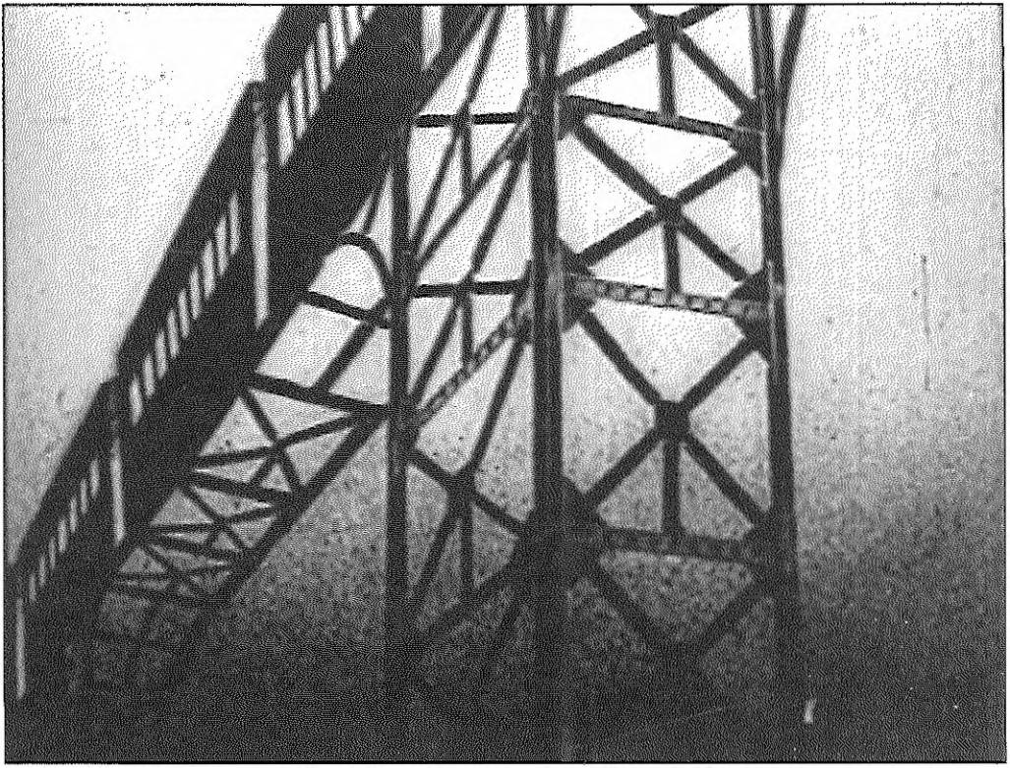

**Figure 1.7.** *Diagonal composition. Train. Still from* The Post.

terminology) and the editing between the shots create a particular rhythm, a flow of images presented one after another in a sort of visual symphony (Fig. 1.6-1.7). There is a sense of uninterrupted movement, which accelerates and decelerates according to the images on the screen. Not only does movement function as a narrative element (the letter passes from hand to hand until it reaches the ad­ dressee), but movement is also used as a differentiating trait among the various postmen around the world - so we see how postmen from Brazil, England, Germany, and Russia seem to have different attitudes, expressed in distinct ways of walking. The pace of life of a given country is presented through a simple portrait of a postman; we have a Russian pace as “sostenuto” and “con forza”, compared to an English “accelerato”, a German “a tempo”, and a Brazilian “rallen- tato”, “semplice” and “tranquillo”. Both in the book and in the film, each postman’s particular walk serves to exemplify a national character and at the same time allows the reader and the spectator to experience the change of rhythm as he passes from country to country. Moreover, the specific beat in the postmen’s movements is underlined by the rhythm of Marshak’s verses in both the printed book and the film’s intertitles.

If in the book the variation of rhythm is perceptible above all through Marshak’s verses, in the film the change in

SOVIET ANIMATION and the Thaw of the 1960s

rhythm is conveyed through an alternation of images and intertitles. The intertitles are presented on the screen with characters of different sizes and shapes, and the diversifica­ tion of the style and design of the letters together with their animation convey the declamatory tone of Marshak’s verses. The letters that compose the intertitles acquire a life of their own - words appear all together in a sentence or one by one, and sometimes words emerge from the black background in discrete units, letter by letter. Letters or words appear at different speeds according to the meaning or intonation of the sentence. The graphic form of the words gains a value on.its own; the words assume a plastic value that goes beyond their content. How can we not think of the Futur­ ists’ claims about the importance of the graphic effects of the written word, of a new visual language, which would maxi­ mize the iconic force of the written word? In this regard it is enough to think about the manifesto “The Letter As Such” written by Velimir Khlebnikov and Aleksei Kruchenykh in 1913. If the Futurists were mainly concerned with hand­ writing, later the Constructivists would develop the notion of the importance of the graphic form of words in typeface. In this vein, El Lissitzky’s works on typography, such as the illustrations for a short picture book for children *About Two Squares (Pro dva kvadrata,* 1922), and for Mayakovsky’s col­ lection of poems *For the Voice (Dlia golosa,* 1923) are particu­ larly significant.42 In articles written in 1923 and 1925, El Lissitzky claims that the printed word should be seen, not

heard, and that typographic form should express through 42 optical means the writer’s gestures and voice.43 In Tsekha- novskii’s film *The Post,* similarly, the plastic aspect of the word fills the void left by the absence of sound.

43

If, on the one hand, *The Post* can be placed within the

heritage of Futurism and Constructivism, on the other hand, it was also influenced by modernists, especially in its use of flat objects on a white screen, geometrical shapes and essential forms with no ornaments, symmetric composition, and space cut by lines - all elements that we find for example in Kazimir Malevich’s paintings. Furthermore, *The Post* is strictly connected to the European avant-garde cinema of the 1920s, and in particular to experimental films by direc­ tors like Viking Eggeling, Hans Richter, Walter Ruttmann, and Marcel Duchamp.44 Even though Tsekahnovskii’s films are not as abstract as Eggeling’s *Diagonal Symphony,* Richter’s

Lissitzky, *For Two Squares;* Maiakovskii and Lissitzky, *Dlia golosa.*

Lissitzky. ‘'The Topography of Typography7’; Lissitzky, “Typographical Facts" (1925) quoted in Mercier, "Posr-Analyse du film de M. Zcchanovsky 1929”, 72.

Also Mercier notes the influence of modernism and avant-garde experimental films on Tsekhanovskii.

**26**

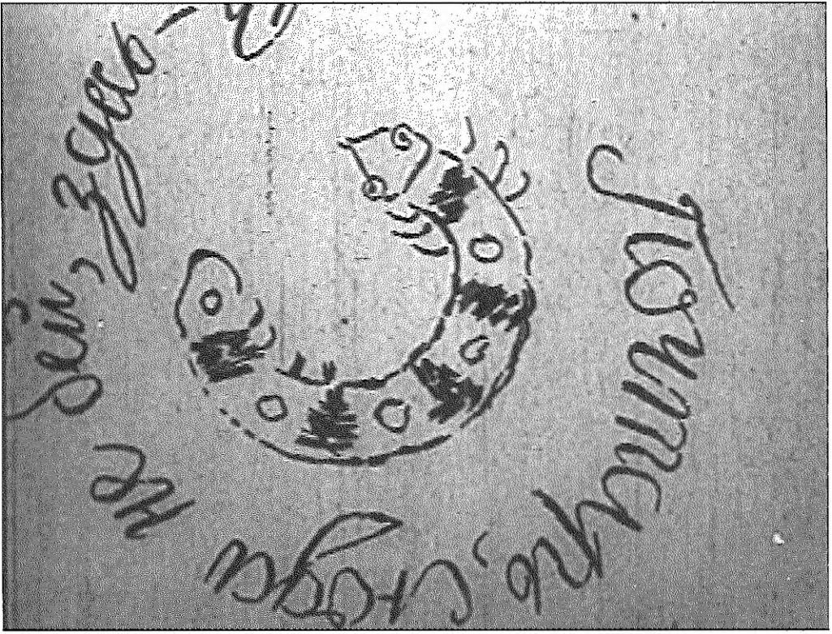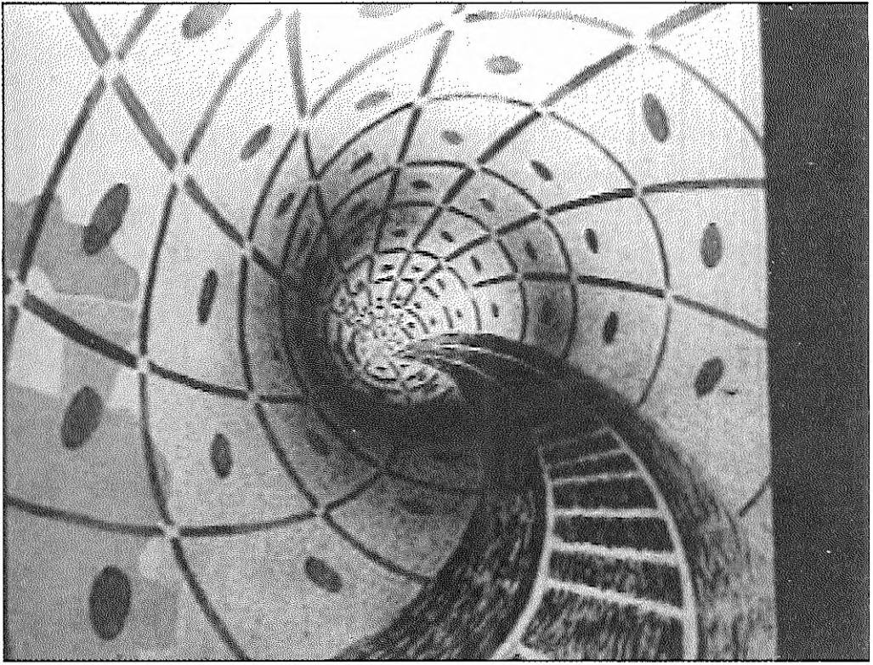

Chapter 1 From Propaganda to Children’s Films

**Figure 1.8.** *Circular Message. Still from* The Post.

**Figure 1.9.** *Tunnel. Still from* The Post.

*Rhythmus 21/23,* Ruttmann’s *Opus I/II/II1,* or Duchamp’s *Anemic Cinema,* they nonetheless share with these experi­ mental films an interest in rotating objects, clashing lines, curves, and geometrical forms, as well as a playfulness that creates a sense of movement and rhythm. A direct similarity is found, for example, at the very beginning of *The Post,* when a boy writes a message for the postman on an envelope

**27**

SOVIET ANIMATION and the Thaw of the 1960s

**Figure 1.10.** *Train. Still from* The Post

(Fig. 1.8); the boy’s circular writing recalls the rotating spiral of Marcel Duchamp’s *Anemic Cinema.* The use of optical effects to show depth (like the tunnel in *The Post,* Fig. 1.9), the multiplication of images, blank backgrounds, quick montage, and abstract forms generated by movements and speed are all recurrent elements in the experimental films of those years; they occur frequently in Tsekhanovskii’s *The Post* and subsequently in his experimental film *Pacific 231 (Pasifik 231,* 1931).

The main trait that Tsekhanovkii’s films have in common with the avant-garde works is their rhythm. As Tsekha- novskii writes in his diary, the content, the essence of *The Post* is pure movement; the “pleasure in looking at this picture should arise from the sensation of an interrupted and diverse movement”.45 The rhythm that Tsekhanovskii cre­ ates in the film underlines the vitality and restlessness of

modern life in general, with its dynamism, speed, energy, 45 and the power of machines. Looking at Tsekhanovskii’s drawings, we recognize the modern faith in technology, the dream of breaking down all the barriers that divide the world. The world he depicts is the modern world always in motion, a world in which steam-engine locomotives, air­ planes, and all other moving machines acquire life of their own in glorifying the new modern industrial and techno­ logical world (Figs. 1.10-1.11).

Written on 24

December 1928. Mikhail Tsekhanovskii. “Dykhanie voli”, *Kinovedcheskie zapiski* 54

(2001): 193. Also in

Tsekhanovskii, "Dykhanie voli’, in *Katalog-al'manakh. Suzdal' 2002,*137.

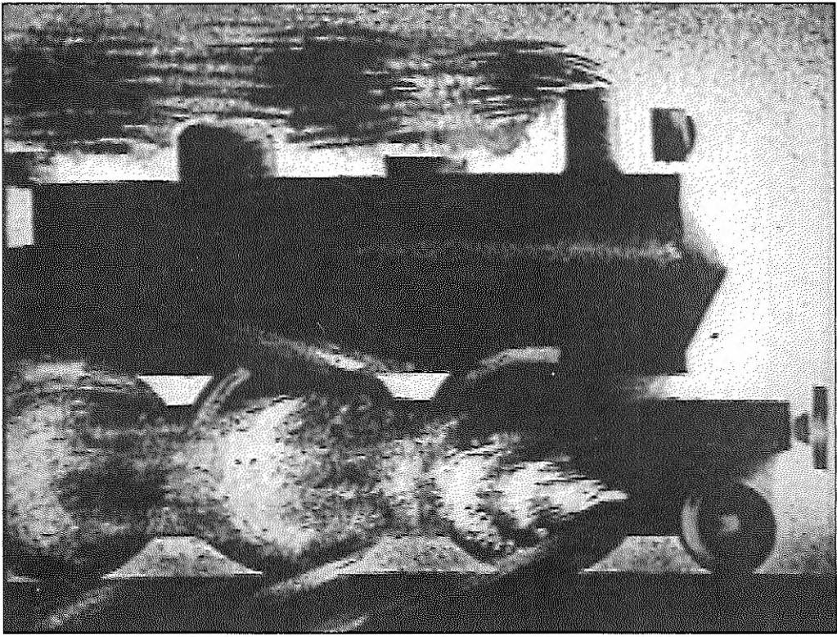

**28**

Having always been fascinated with technology, Tsekha- novskii could not witness with indifference the new tech­ nological revolution brought by the introduction of sound in cinema. He dedicated the decade before World War II to experimentation with synchronization of sound and images.

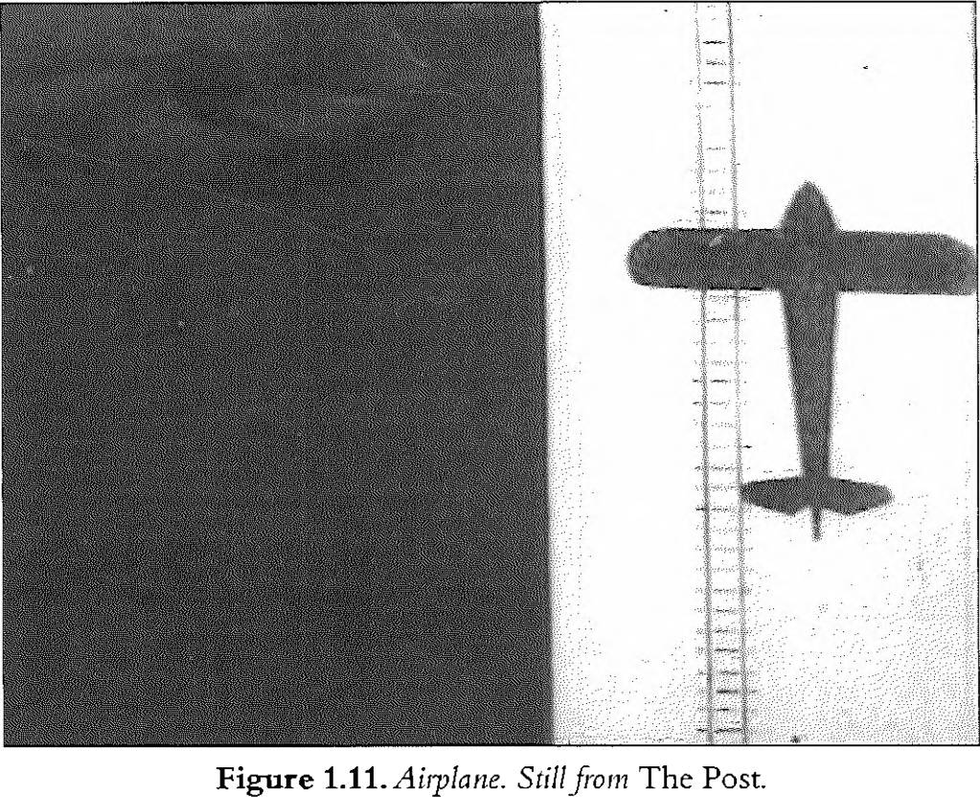

46 Taylor and

Christie, *The Film Factory,* 234-235.

## The advent of sound: Tsekhanovskii’s experiments

At the beginning of the 1930s, a new technological innova­ tion was made in cinema: the introduction of sound in film. It is well known that the main directors of the Soviet school of cinema were against this innovation when it first ap­ peared, or at least desired to utilize this feature in non-natu- ralistic ways - at this propos Sergei Eisenstein, Vsevolod Pudovkin and Grigorii Aleksandrov wrote the manifesto “Statement of Sound” (“Zaiavka”) published in the journal *Zhizri iskusstva* in 1928.46

It is true that generally the advent of sound presented a whole series of new problems, also for animation. In fact, in animated films, sound has a complex function; image and sound have to be synchronized, so that the characters not only “talk”, but also their movements produce sound and correspond to the rhythm of the music. As we know now, there are two methods for recording sound in animated

films: the first is to film the images and subsequently record the sound over them (post-synchronization); the second is to work out a preliminary soundtrack and shoot the film according to the sound scheme. This latter method gives a better synchronization of image and sound, and it is in general the technique used by contemporary animators.

However, for the first Russian sound animated movie *(The Post),* sound was post-added to an already existing silent film, and in the Soviet Union of the 1930s, post-synchroni­ zation was generally used, such as in *Black and White (Bick end nait,* 1932), a film made by Leonid Amal'rik and Ivan Ivanov-Vano in 1932 to illustrate some of Mayakovsky’s verses. Soon the animators realized that this method would not result in perfect synchronization and they started to search for new methods and techniques.

Tsekhanovskii was a pioneer in this area; he was the first in the Soviet Union to conceive of the possibility of building an animated film on an existing soundtrack.47 For Tsekha- novskii it was not simply a question of the synchronization of image and sound; he went as far as considering sound as the organizing principle, as the dominant feature to which the entire structure of the visual images would be subordi­ nated.

A good example of this approach to sound would be an experimental film made by Tsekhanovskii in 1931, *Pacific*

*231.* In this film Tsekhanovskii tried to interpret visually a famous symphonic work, Arthur Honegger’s symphony *Pacific 231* (written in 1923), considered by most music critics the first example of musical inspiration derived from the modern poetry of machines, energy, and speed. The full title of the film was: *Pacific 231: a Symphonic Poem about the Steam-Engine Locomotive of Arthur Honegger, Performed by the Symphony Orchestra Conducted by A.V.Gank (Pasifk 231 sim- fonicheskaia poem a o paravoze Artnra Oneggera, ispol'niaet sim-*

*fonicheskii orkestr pod npraideniem dirizhera Sofia A.V. Gauk).* 47 The finished film resulted in a live-action (thus non-ani- mated) short, but during its creation, Tsekhanovskii thought several times of introducing drawings and animated objects into the sequence of photographic images. Only gradually did he understand that animated elements would

not fit harmoniously into this type of experimental film. His research and his experiments with sound for *Pacific 231,*

Sec his articles: Tsekhanovskii. “Spctsifika Tonfil'nia"; Tsekhanovskii. “O zvnkovoi risovannoi fil'me’’: RGALI.

‘'Protcssional'no-

technicheskii opyt:

*Pasifik".* 53-54.

48 RGALI.

'i’rofcssional'no- tcchiiichcskii opyt: *Pasiftk".* 53-54.

however, were very useful for his future animated films and for Soviet animated films of that time in general.

Tsckhanovskii, in working with Honegger’s symphony, sought to reach an absolute rhythmic correspondence be­ tween the music and the rhythm of the movements inside the frame, as well as between the music and the rhythm of montage. He approached Honegger’s symphony in the same way as he used to approach the text of a literary work in order to create illustrations for it - this film looks like a filmic illustration of a musical work. The film follows three main visual themes: the steam-engine locomotive, the conductor directing the musicians in the orchestra, and the musicians with their instruments. An artistic unity in the work is achieved by coordinating in parallel external similarities of movements and similarities between forms of objects, and by associating precise visual elements with specific sounds. As he explained in his article about *Pacific 231,* the director meant to film synchronically the orchestra playing the sym­ phony in several planes with different groups of instruments at the same time, in such a way that the visual frames could help the listener to perceive the rhythmic, melodic and semantic design of Honegger’s work.4S

As the spectator watches Tsekhanovskii’s film, a continuous stream of images and sound captures him and brings him into a dimension where sound and visual elements from different worlds melt together. Human beings are repre­ sented in discrete units, in modernistic fragmented images (hands, lips, cheeks of the musicians and partoftheir instru­ ments), and men themselves become objects, machines. As the music already intimates, the film is an apotheosis of the powerful machine, of the strength and the purposefulness of the industrial force. Images of musical instruments and musicians are superimposed over details of the steam- engine locomotive. Windows of a train wagon, telephone poles, traffic lights, and streetlamps arc glimpsed fleetingly on a background representing the orchestra playing.

Tsekhanovskii’s experiments were not concerned only with formal questions; he always had in mind the revolutionary message he wanted to convey to the spectator. If *The Post* was a celebration of human work (with the aid of the most modern technological discoveries, especially in transporta­ tion), *Pacifc 231* was mainly a celebration of the machine.

In one of his unpublished articles, Tsekhanovskii voiced his enthusiasm for the advent of sound in Soviet film; he welcomed sound as a means of expressing completely and thoroughly the ideas that lie at the base of filmmaking, that is - he said - the ideas of the construction of socialism.

The more paths we take over from the very outset, the more deeply we engage with the entire spectrum of sound in cinema, the more quickly we will reach our principle goal. We possess the material and the tools of this new art form in order, possibly, to fully reveal the colossal ideas of our Socialist construction.49

Sound was indeed strictly connected with technological evolution and technological researches in the new Socialist state, which had been seized by enthusiasm for industriali­ zation.

Not only was Tsekhanovskii interested in sound film, but he was also fascinated with the experiments done in the Soviet Union with “drawings of sound”. According to an anecdote reported by the Russian film critic and scholar Nikolai Izvolov, Tsekhanovskii was in the Leningrad studio during the sound recording of Abram Room’s film *The Plan for Great Works (Plan velikikh rabot,* or *Piatiletka,* 1930), which was the first Soviet sound film. In this laboratory, three people were looking at the developed film in question: Tsekhanovskii, the composer Arsenii Avraamov, and his technical assistant, the engineer Evgenii Sholpo. They ex­ amined the soundtrack marks on the film for the first time, and noticed how they appeared in the form of a curved line; each of these three men thought that if they drew a curved line of their own instead, it should somehow generate sound?0

Tsekhanovskii never engaged in such a difficult enterprise. Instead, Avraamov and Sholpo began to do research in the field, producing some interesting works. At the beginning of the 1930s, after obtaining some initial successes in the

creation of artificial sounds, they founded an institute in 49 Moscow dedicated to artificial sound research - the Scien­ tific Research Cinema and Photographic Institute. Later on, Avraamov and Sholpo were joined by Nikolai Voinov and Boris Iankovskii. While Avraamov was more interested in

the sounds of the simplest, most basic geometrical forms, 50

Voinov would look for a more practical and easily applicable

RGALI,

Tsekhanovskii fond 2627, op.l, d. 92,11. 13-17 “Ne

prevyshchen li protsent oshibok?” 1931.

Izvolov, *Fenomen kino,* 269-270.

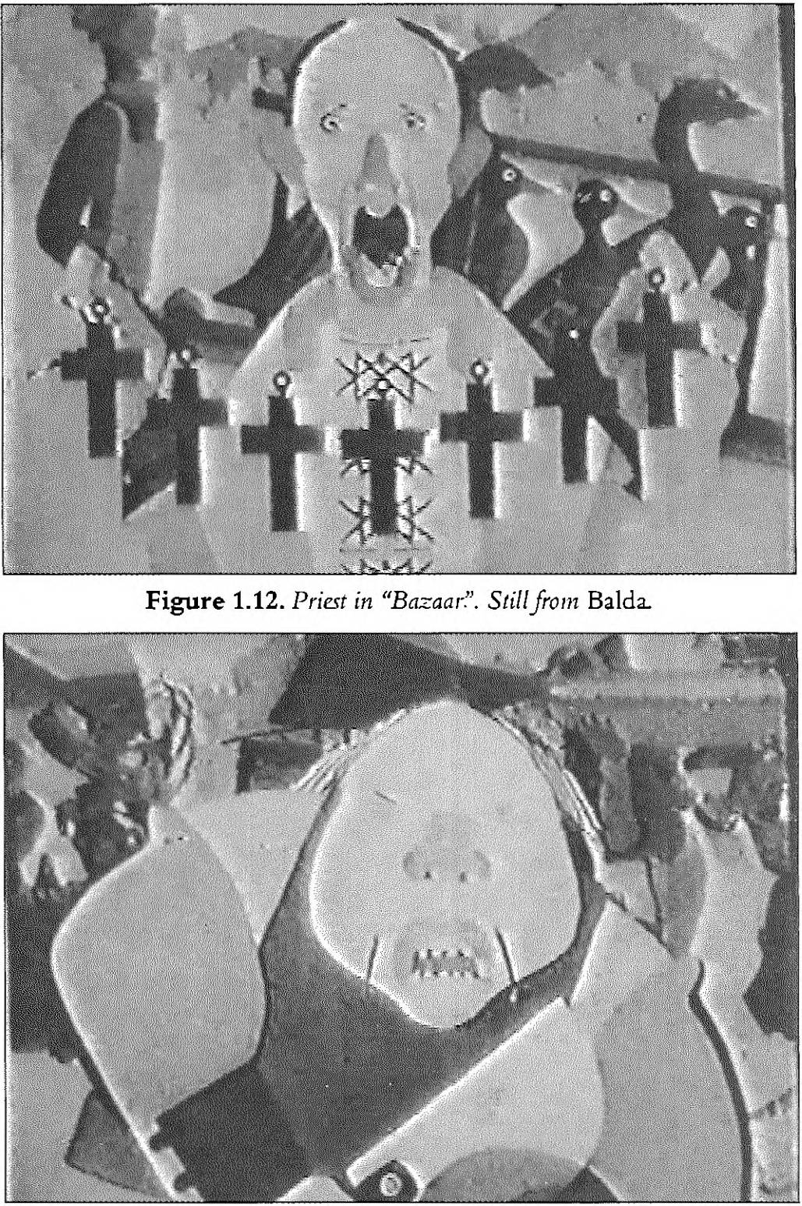

Chapter 1 From Propaganda to Children’s Films

**Figure 1.13.** *Merchant in “Bazaar”. Stillfrom* Baida.

system for the production of animated films, and he used paper cut-outs to reproduce specific sounds.

By 1932 Avraamov’s laboratory was ready to synthesize human speech using circles, triangles, and squares, but the State blocked financial aid for the experiments and the staff could not afford to continue their research. Incidentally, it is curious to notice how at the same time that the Soviet schools of synthetic sound were exploring the possibilities of sound drawing, similar experiments were undertaken

**33**

SOVIET ANIMATION and the Thaw of the 1960s

**Figure 1.14.** *BearShoiu in "Bazaar”. Still from* Baida.

independently in Germany by Oskar Fischinger and Rudolf Pfenninger. In this regard, Ivanov-Vano recollects how he suddenly read in the German journal *Filmtechnik* (1932, N. 23) that for the first time in the world, an exhibition in Germany showed short films in which the sound was cre­ ated without using a microphone. Those were works by 51 Pfenninger.51 The Soviet experiments on generating sound through drawings have been almost completely forgotten, 52 even though such a famous experimental animator as Nor­ man McLaren is believed to have been aware of this research and to have been influenced by it.52

Tsekhanovskii was fascinated by the theoretical possibilities of rendering sound in drawing, but he was never directly involved in the research; he would examine these experi­ ments only in the light of his studies on the synchronization of images and sound. *After Pacific 231,* the director embarked on new experiments with sound, this time utilizing ani­ mated techniques, and created an animated opera based on Pushkin’s fable *The Tale of the Pope and his Worker Baida (Skazka 0 pope i rabotnike ego Balde,* Figs. 1.12-1.15).

Dmitrii Shostakovich, who started to work with Tsekha­ novskii in 1933, composed a musical score exclusively for this animated film. Ultimately, by 1936, the composer’s work on this score generated fifteen pieces that became his

Ivanov-Vano, *Kadr za kadrom,* 91.

In *Kadr za kadrom,* Ivanov-Vano mentions that Norman McLaren was well acquainted with

the experiments of the Russian inventors of sound drawings because he had helped to translate into English the Russian text *Animated Film,* a book published in Moscow in 1936 in which all these experiments are systematically described (Zil’ver. ed., *Mul'tiplika- tsionnyi fd'm).*

Ivanov-Vano, *Kadr za kadrom,* 92.

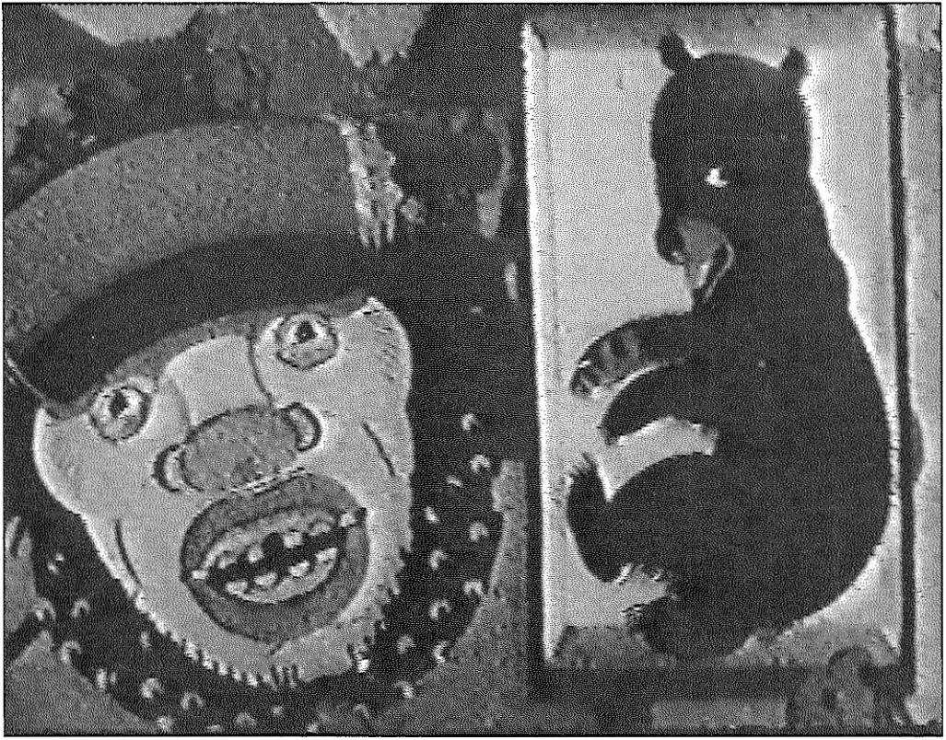

**34**

Chapter 1 From Propaganda to Children’s Films

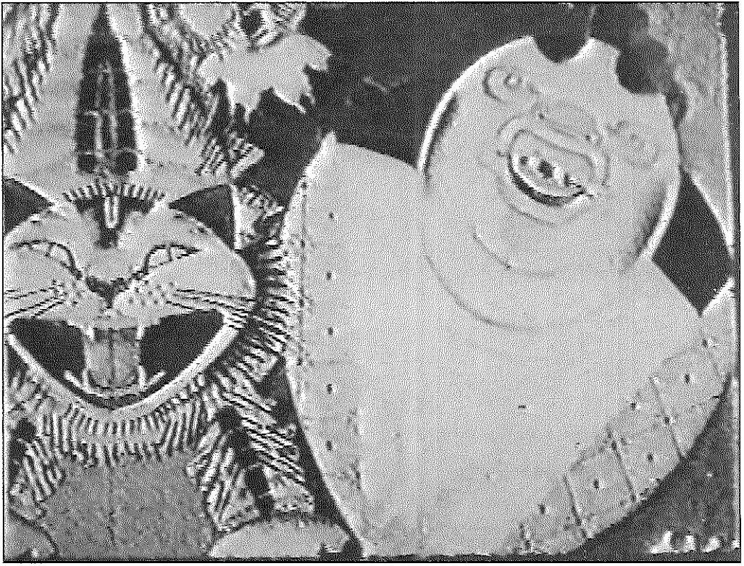

1. In his diary on the date 24 February

1936,

Tsekhanovskii noted that he was going to finish *Baida,* a stronger and more mature film, in his opinion, than *The Post.*

Tsekhanovskii, “Dykhanic voli”, *Kinovedcheskie zapiski* 54, 187.

**Figure 1.15.** *Woman and Cat in “Bazaar”. Still from* Balda.

op. 36. In his diary, Tsekhanovskii mentions that *Baida* was almost completed,33 but the film was never released and all we have remaining from it is a few minutes of one scene entitled “Bazaar”. The characters here are grotesquely de­ picted, and with their simplicity and the mechanical quality of their movements they look like caricatures of the mer­ chants and priests described by Pushkin. Their mechanical movements perfectly correspond to the rhythm of the shrill and somehow mechanical (puppet-like) music of Sho­ stakovich; they also correspond to the precise rhythm of the verses written for the film by the OBERIU poet Aleksandr Vvedenskii. It should be mentioned that there is an affinity and friendship between Tsekhanovskii and the OBERIU group on the basis of their works for children’s books and of their avant-garde works. Tsekhanovskii was especially close to Aleksandr Vvedenskii, who contributed to *The Tale of the Pope and his Worker Baida,* and Daniil Kharms, who wrote the words for the *compere* of the film *The Post.*

It is unfortunate that, as happened to many experimental artists of the time, the increasing attacks on Tsekhanovskii’s graphic style and Shostakovich’s music for “formalism” prevented their completing the film. Tsekhanovskii in his diary explains how the article “Muddle Instead of Music” (“Sumbur vmesto muzyki”), which appeared in *Pravda* in 1936 attacking Shostakovich and other “formalists” (such as

**35**

SOVIET ANIMATION and the Thaw of the 1960s

the theatre director Vsevolod Mcycrhold) was the main cause for shutting down the work on *Baida.* Had this film been released, Soviet animated cinema might have devel­ oped differently. With the imposition of socialist realism and the subsequent creation of the centralized studio Soiuzdetmul'tfirm in 1936, which was oriented exclusively towards animated films for children, all such experiments came to a halt.

## The 1930s: the last satirical animated films

Around 1936, not only were stylistic innovations hardly accepted, but also films that aired political and social themes soon could no longer be made. In order to understand the peculiarities of the Soviet animated films made in the early 1930s and how Soviet animation could have developed if authorities did not reject in toto satire, one should think about the last satirical animated films of these years, *Black and White (Bick end nail,* I. Ivanov-Vano and L. Amal'rik, Mczhrabpomfil'm, 1932), *The Tale of the White Bull-Calf (Skazka pro belogo bychka,* V. Sutccv, L. Atamanov, Mczhrab- pomfil'm, 1933), *The Little Music Box (Organchik,* N. Kho- dataev, Soiuzfil'm 1933), and *The Tale of Tsar Duraudai (Skazka o tsare Durandae,* Ivanov-Vano and B. and Z. Brum- berg, Mczhrabpomfil'm, 1934). These films, based on attacks on rich, racist, and two-faced capitalists, followed the poster-style of Mayakovsky’s *Okna ROSTA* (as in *Black and White),* the journal caricature style of the early 1920s (as in *The Tale of the White Bull-Calf),* or a manner closer to folk art, wood engravings, and traditional toys (as in *The Little Music Box).*

*Black and White* was an adaptation for the screen of Mayakovsky’s homonymous poem using poster and graphic style that recalled his drawings as well as the tradition of the Revolutionary poster and agitprop films. The drawings and the words, recited in a bombastic tone following Mayakovsky’s style, matched the rhythm and structure of the poet’s verses. As in the poem, inspired by Mayakovsky’s visit to Cuba, the Cuban workers appear under the yoke of American domination, victims of severe racist treatment.

*The Tale of the White Bull-Calf* was a political satire on the theme of nuclear disarmament. In it, various animal figures

representing League of Nations members - a Fox, Hyena, Snake, Lion, Tiger, Hippopotamus, and Crocodile - were depicted in ways that suggested their hypocrisy in facing the problem of nuclear disarmament, while the Soviet Union presented a contrasting positive image of a young Pioneer.

While the first two films attack capitalist countries, *The Talc ofTsarDuraudai* and *The Little Music Box deal* with the touchy subject of the ineptitude of rulers. The treatment of such a topic in these two films was read by the authorities as a criticism of the contemporary system and probably helped bring about the authorities’ subsequent total rejection of any type of satire in animated films.

*The Little Music Box,* made in 1933, was criticized by the press for its “incorrect interpretation of Shchedrin’s satire”,M and for “deviation from the social and historical concreteness of the period of reaction under Nicholas”?3 Fortunately Saltykov-Shchedrin’s works were still in favor with the Soviet leaders, thus no serious consequences resulted from this criticism. In his film, Khodataev emphasized the puni­ tive function of the rulers in Saltykov-Shchedrin’s story right at a time when the country was experiencing dekulaki­ zation, forced collectivization of the peasantry, and terror unleashed because of famine. The repression of the peasants in the film could be seen as a direct allusion to the contem­ porary situation, while a scene where books burn in a library could be a reference to Soviet censorship. Potential allusion to contemporary society becomes even more marked towards the end of the film, when the governor arrives at a contemporary city, which has a clear Constructivist character.

1. Volkov.

"Miil'tiplikatsiia". 113.

1. Volkov.

“Mul'tiplikatsikr. 116.

The modern architectural style of the buildings in this scene sharply contrasts with the stylistic choices adopted in the rest of the film, which reflect the traits of traditional wooden toys and Vladimir Favorskii’s wood engravings. In particu­ lar, the vivid character of Favorskii’s engravings was faith­ fully reproduced by his disciple Georgii Echeistov, who participated in the creation of this film together with Daniil Cherkes. *The Little Music Box* and *The Talc of Tsar Duraudai* were the last two Soviet films that adopted this stylized manner and had satirical content. Soon animation under­ went a change of direction.

SOVIET ANIMATION and the Thaw of the 1960s

## A change of direction: animation for children only, the Disney influence

After the First Congress of Soviet Writers in 1934, when socialist realism became officially the mandatory canon to follow in art, most of the animators moved away from traditional Soviet animated films with ideological messages and began to create mainly films intended to entertain or educate the young audience. The decision to orient anima­ tion production towards films for children was in part a political choice, and in part due to Disney’s influence on Soviet animation. In 1935 at the First International Film Festival in Moscow, some Disney animated films were screened to the general public with great success. The influ­ ence of American productions affected the choice of themes and style in Soviet films. Several Soviet animators enthusi­ astically embraced the American films’ comic gags, slight plot development, and Disney’s typical “roundness” of char­ acter outline. The adoption of Disney’s style also had some political consequences, especially at a time when Stalinism insisted on cinema as an art form for the masses. Boris Shumiatskii, the head of the newly created Soiuzkino and later the deputy chairman of the GUFK (Chief Directorate of Film and Photo),56 urged the need for “a cinema for the millions” and the necessity of following socialist realism in film, renouncing any formalism, and creating a “cheerful and joyful spectacle”.57

Paradoxically, at a time when the import of foreign film was 56 drastically diminishing, Shumiatskii was fascinated by American studios, and intended to build a Soviet Holly­

wood in the Crimea; he even traveled to the United States to study the American film industry in order to realize his project, but his dream never materialized - Shumiatskii was

arrested and executed in 1938.58 A similar visit to the United States, this time to animation studios, was made by Viktor Smirnov, who, after learning the techniques used for drawn 57 animated films at the Disney studio59 in 1933, came back to Russia bringing new technologies and a new approach to­ wards animation in general. In 1934, a new studio, “Smir- 58 novaia studiia”, was created and linked to Mosfil’m. The

eight films produced there over three years had mainly an entertainment purpose and were full of comic gags, 59 although they were definitely of poorer quality and vivid-

GUKF - Glavnoe upravlenie po proizvodstvu khudozhestvennykh fil'mov, founded in 1933. In 1937 his

tide was simplified to GUK- Chief Directorate of the Film Industry.

Shumiatskii, “A Cinema for the Millions (Extracts)”, 368.

Taylor, “Ideology as Mass Entertainment”, 213-216.

Elizarov, *Sovetskaia inul'fiplikatoiia,* 207.



1. Especially

Tsekhanovskii and Khodataev. See for example Tsekhanovskii, “Ot Murzilki k bol'shomii iskusstvu”; and Khodataev, “Iskusstvo mul'tiplikatsii",

66-69.

1. Giannalberto Bendazzi, *Cartoons,* 2-21; Fumiss, *Art*

*in Motion,* 19-20; Crafton, *Before Mickey,* 150-155.

ness then their American counterparts. However, not all the artists were willing to conform to the slogan “Give us a Soviet Mickey Mouse!” (“Daite nam sovetskogo Mikki Mausa!”) which was announced at the 1933 All-Union Conference on Comedy (Pervoe vsesoiuznoe soveshchanie po problemam komedii), where issues concerning laughter and comedy in Soviet feature and animated films were discussed. During this meeting the supporters of Smirnov and of the Disney style he promoted clashed with some of the most talented directors (including Mikhail Tsekha­ novskii, Nikolai Khodataev, and Ivanov-Vano), who tried to oppose the tendency to blindly imitate Disney-style. Some of them wrote articles in journals and publications;60 some directly intervened with speeches at the 1933 conference, defending the singular qualities of Soviet animation and vehemently opposing American film style and themes. Nev­ ertheless, these attempts did not succeed in arresting the shift in Soviet animation.

The quality of the films in the American style released by the Smimovaia studiia could not compare with the Ameri­ can technological perfection. Smirnov introduced celluloid sheets in Russia only in 1933-1934, while in America the technique had been known for two decades, although not always used by American studios because of the high costs of royalties and of cel sheets in comparison with cheaper paper. In America, Earl Hurd, who used celluloid sheets to draw characters and then apply them over painted back­ ground sheets, patented cel technique already in 1914. Al­ most at the same time John Randolph Bray patented an alternative technique, which utilized cel sheets for painting scenery and then applied them over the drawings to be animated. Bray and Hurd formed together the Bray-Hurd Patent Company and earned healthy profits from royalties until 1932, when the patents expired. When the patent came into public domain, studios tended to use cel more often, since the costs diminished. Soon cel animation became the industry norm.61 The celluloid sheets in the Soviet Union were of inferior quality to those available in America. The American cel sheets used at the end of the 1930s were of a good transparent quality that could allow juxtaposition of a few layers, while the Soviet cels had a slight grey or yellow tinge that would cause a considerable darkening of the drawing when more than three layers were used at the same

SOVIET ANIMATION and the Thaw of the 1960s

time.62 For a comparison of the retrograde techniques avail­ able in the Soviet Union, one can think ofWalt Disney’s use of the multiplane camera already in the *Silly Symphonies* film *The Old Mill* (1937) and partially in *Snow White and the Seven Dwarfs* (1937). This special device allowed the placement of cel sheets with characters and background scenery on super­ imposed glass planes, so that the different layers, seen from a perpendicular camera, could convey a three-dimensional composition and an enhanced quality of depth. In compari­ son with the results already obtained by Disney animation at the end of the 1930s, Soviet animation was developing slowly. The new system, however, enabled the Disney style to spread among Soviet animation artists and permitted the rate of production of animated films to increase drastically.

The use of drawings on cel, in fact, lent itself to a subdivision of work similar to that of an assembly line. Animated films became products of collective work, with the animators performing small and repetitive tasks. In this way produc­ tion was greatly accelerated, but the end product, which had passed through several hands, tended to become stand­ ardized. Disney’s style became dominant, especially the characteristically round outlines of his characters and his particular way of depicting the animals. As Crafton notes, a shift towards rounded traits had happened also in early American animation (see for example the transformation of the look of Felix the Cat). Crafton points out some aesthetic, economic, and psychological reasons for this change. Firstly, he notices how a rounded shape made Felix seem more cuddly and sympathetic; secondly, “circles were faster to draw, retrace, ink and blacken”; thirdly, animators seemed affected by what Gestalt psychologists call “shaping”, a natu­ ral tendency to drift towards simple (circular) forms.63 This approach, thus, suited animation for children and allowed increased production, but also worked against cultivating a distinctive style.

Indeed, this system made possible more centralized control 62 over the activity of the animators, a control that followed the desire of the Soviet authorities to limit the artists’ freedom

of expression. It was not by chance that techniques such as 63

cut-outs and puppet animation, in which the director had to follow the entire development of the film-making proc­ ess, were not used again until the late 1950s.

Ivanov-Vano. “Graficheskaia nnil'tiplikatsiia". 172.



Crafton. *Before Mickey. M3.*

Crafton also rulers

to Arnheini. Iwiu/

*Thinking.* 194—200.

1. Sec Khodataev. “Pridia iz neizvestnosti. ia i ukhozhu v neizvestnost'". IS6-I90; and

Khodataev. “Iskusscvo nnd’tiplikatsii”. 67.

1. Sec Borodin, “Aniniatsiia podncvol'naia". *Kiiiograf* 16. 140. Sec also Anial'rik’s interview in the TV series

*Aiiiiiitiisiia ot* .4 *do IA.* dir.

Liakliovctskii and Margolina.

In order to strengthen control over the activity of inde­ pendent animators even further, the production of films came to be organized in a centralized location. A new studio, “Soiuzdctmurtfirm”, was created in 1936 to centralize the animated film industry and replace production by small groups or individuals. Animators from Viktor Smirnov’s studio, as well as from studios based at Mezhrabpomfil’m and Mosfil’m, began to work at Soiuzdctmurtfil'm. The particle ‘det’ in the name of this studio (from detskii - for children) is symptomatic of the tendencies in animated films of these years, whose primary goal was the ideological and aesthetic education of young audiences. Later on the particle “det” was cut and the studio took its current name “Soiuzmul'tfirm”, but the tendency to produce only ani­ mated films for children lasted until the 1960s, when one began to see tentative signs of a renewal in style and theme.

With the creation of the studio Soiuzdctmurtfil’m, the in­ dependence of several small groups came to an end; artists and directors with different artistic orientations had to work together and be subjected to direction by supporters of the Disney style. Some of the artists, realizing the impossibility of fighting against the dominance of Disney’s style, left the studio. This was the case with the famous artist Nikolai Khodataev, who refused to produce frivolous and stand­ ardized films and abandoned in toto animation in order to fully dedicate himself to sculpture.N

Strict control over animation also broke through post-pro- duction. An increasing number of films began to be cen­ sored, including some films that did not seem to have any reference to contemporary politics. As an example it is enough to recollect how Sutccv and Amal'rik’s *Kolobok* (1936), a film based on the traditional Russian tale of the same name, in spite of no particular reference to actual situations, was accused of distortion of reality and caricature in its image of the kolkhoz. A year later, another film by Sutccv made with the collaboration of Amal'rik, *A noisy voyage (Sluiinnoe plavanie,* 1937) was first accepted under Shumiatskii’s direction, but in 1938-1939, after Shumiatskii’s execution, the film was attacked on the basis of a changed attitude towards foreign music,jazz in particu­ lar, and for not representing Soviet reality/0 Nationalist concerns began to be noticeably predominant with the

SOVIET ANIMATION and the Thaw of the 1960s

approach of World War II, when Soviet animation experi­ enced a brief revival of films for adults with political themes.

## The animation of World War II and the restrained reawakening of political films

The pre-war atmosphere stirred a brief and temporary re­ turn to political films. Mythification of the past, exaltation of the present, and apotheosis of a brilliant future found expression through new patriotic films. They showed that an alternative path in the development of animation was still possible following the lesson taught by animated films of the 1920s and not limiting production to films directed at chil­ dren’s entertainment and education. The film *Victorious Des­ tination (Pobednyi marshrut,* D. Babichenko and L. Amal’rik, 1939), after glorifying the 5-year-plans and the Stakhanovist movement, ends with a train representing the All-Union Communist Party speeding towards the direction pointed by Lenin. In other films, an accent on future successes gives way to the celebration of idealized pasts, a tendency started by live-action films of these years, such as Vladimir Petrov’s *Peter I* (1937-38), Sergei Eisenstein’s *Aleksandr Nevskii* (1938), and Vsevolod Pudovkin’s *Minin and Pozharskii* (1939) and *Suvorov* (1941). One of the first animated films following this trend was *Militant Pages (Boevye Stranitsy,* D. Babichenko 1939, also translated as *War Chronicle),* a short consisting of a series of animated posters *(kinoplakaty)* that surveys the history of the Soviet Union from the Civil War to the Stalinist era.

In 1938, the idea of introducing political ideas in satirical form was actualized in the animated journal *The Political SatiricalJournal No. 1 (Zhurnalpolitsatiry N.* 1, D. Babichenko,

I. Ivanov-Vano, A. Ivanov, V. Polkovnikov, L. Amal’rik, 1938). The series released only two films in 1938 and 1941. Of these, the first issue has not been preserved; the second issue, *Political Satirical Journal No. 2 (Zhurnal politsatiry N. 2,*

I. Ivanov-Vano, A. Ivanov, O. Khodataeva, Z. and V. Brum- berg, 1941) focuses on the fight against Hitler and Fascism. This topic reappears in other films of the same years, such as *How Vasia Terkin Went to Be Recruited (Kak Vasia Terkin prizyvat'sia shel,* P. Shmidt, V. Siumkin, 1941); *Cinemacircus (Kinotsirk,* O. Khodataeva, L. Amal’rik, 1942); and *He Sur­ passed (Prevzoshel,* V. Mudzhiri, Tbiliskaia kinostudiia,

Chapter 1 From Propaganda to Children’s Films

1942). The most interesting films following these national­ istic subjects were *The Fascist Boot Won't Trample the Soil of Our Motherland (Ne toptat' fashistskomu sapogu nashei rodiny,* Ivanov-Vano, Ivanov, 1941), in which the popular march “The armor is strong, and our tanks are fast ...” (“Bronia krepka, i tanki nashi bystry ...”) performed by the famous Aleksandrov ensemble emphasizes the patriotic spirit; and *When Goebbels Does Not Lie (Kogda Gebbel's ne vret,* S. Fedor- chenko, Goskinprom Gruzii, 1944), which combines ani­ mation with documentary footage.

A few more films featuring patriotic themes or political caricature were produced by Dmitrii Babichenko, Ivan Ivanov-Vano, Aleksandr Ivanov, and Panteleimon Sazonov, using the style of the famous agitation posters of *Okna TASS (Windows TASS -* The Telegraph Agency of the Soviet Union), which were agitational political posters released during the years of World War II, continuing the tradition of the *Okna ROSTA* of the 1920s. An isolated experiment but worth mentioning, the film *Three Girlfriends (Tri podrugi,* P. Shmidt, Lenfil'm, 1941), about three girl-Pioneers who embark on a long flight to the Arctic, introduced in anima­ tion one of the favorite topics of the High Stalinist era: expeditions and aviators.

In general, during the war, animation production dimin­ ished considerably. In addition to the political film men­ tioned above, only a few films for children appeared in 1940 and 1941 atMosfil’m, Soiuzmul'tfil’m, and Lenfil'm. In 1940 at Mosfil’m, Viacheslav Levandovskii and Georgii Elizarov, with the help of the famous puppet theater director Sergei Obraztsov as artistic consultant, produced a puppet film for children called *In the Land of the Dolls (V kukol'noi strane).* In the same year four animated films for children, this time drawn, were made at Soiuzmurtfil’m, *And We, Too, to the Olympiad (I my na Olimpiadu,* V. Suteev), *Ivas (Ivos',* Ivanov- Vano), *The Little Bear (Medvezhonok,* A_ Evmenenko), and *Favorite Heroes (Liubimyegeroi,* D. Babichenko), a film dedi­ cated to the 20th anniversary of Soviet cinematography. Two other films were produced at Lenfil’m, *The Tale of the Stupid Little Mouse (Skazka o glupom myshonke,* M. Tsekhanovskii) and *Circus (Tsirk, A.* Sinitsin). In 1941, only three films for children were made at Soiuzmul'tfirm stu­ dio, two of them were adaptations of Kornei Chukovskii’s tales, Leonid Amal’rik and Vladimir Polkovnikov put on-

SOVIET ANIMATION and the Thaw of the 1960s

screen *Barmalei,* while V. Suteev adapted *The Fly-Tsokotukha (Mukha-tsokotukha)',* P. Sazonov and Lamis Bredis, instead, referred to Krylov’s fable in their *The Elephant and the Pug (Sion i tnos'ka).66*

Soon the studios in Leningrad and Kiev closed, the studios in Erevan and Tbilisi released only a few films, and the Moscow studio Soiuzmul’tfil’m was evacuated to Samarkand, where, suffering from lack of means, it barely kept on functioning.

## Animation after World War II: fables and folk art

When the studio Soiuzmul’tfil’m returned to Moscow, the production of animated films was slowly set in motion again. Some directors from Leningrad, such as Tsekha- novskii and Mstislav Pashchenko, and later the Armenian Lev Atamanov, joined the Moscow studio; while young artists like Lev Mil’chin, Anatolii Sazonov, and Evgenii Migunov also took part in the new collective. These new animators came from the well-known cinema institute VGIK *(Vsesoiuznyi gosudarstvennyi institut kinematografii* - All­ Union State Institute of Cinematography), where in 1938 regular courses started to prepare artists for live-action and animated films. Courses came to a stop during the war, when the director Ivanov-Vano - who was one of the foun­ ders of the new department of animation inside the Faculty of Art - together with other members of the studio Soiuz- mul’tfil’m evacuated to Samarkand. After the War, Ivanov- Vano continued to give courses at VGIK and at the Soiuzmurtfil’m studio, and for -the rest of his life he kept teaching as much as working in the studio.67

In the post-war years, animation artists working at Soiuzmurtfil’m had to abandon once more the satirical and propagandistic films, with their poster and caricature style adopted during the war, in order to follow the studio’s mandate of producing animated films for children. The animated films for children made in Soiuzmurtfil’m had a 66 moralizing emphasis and promulgated values such as friend­ ship, loyalty, comradeship, honesty, and the triumph of justice. Features of these animated films - a positive attitude towards the Socialist world, the victory of the good over the 67 bad, the values of comradeship and sharing - recall themes

Mach ere t and Glagoleva, *Sovetskie khudoxhestuen nye Jll'my.*

Ivanov-Vano, *Mul'tiplikatsua vchera i segodnia.*

Chapter 1 From Propaganda to Children’s Films

found also in live-action films made during the Stalinist period. The language used in animation followed Lenin’s dictum that cinema had to be made for the masses, even more so in the case of children’s animation, in which the language is absolutely simplified in order to be comprehen­ sible to a young audience. It seems that Soviet animation explicitly took upon itself the role of educating a particular segment of society, one that would be responsible for the future of the country. The didactic tone used in animation followed the tendency in Stalinist art to present a society that was working towards the realization of a perfect socialist world. The education of children was considered of vital importance to the creation of the new world. Youth organi­ zations of the young Pioneers and the older Komsomol helped to spread ideological and universal humanistic val­ ues, which were promoted through children’s literature and films, as well as cartoons made for children.

In terms of the aesthetics of the films, the most talented artists (such as the sisters Valentina and Zinaida Brumberg, Ivan Ivanov-Vano, Lev Atamanov, Leonid Amal'rik, Vladimir Polkovnikov, Evgenii Migunov, Panteleimon Sa­ zonov, and Mikhail Tsekhanovskii, to mention a few), while still following the main naturalistic style brought by “Dis­ ney’s revolution” and adopting Disney’s style to such an extent that some of the characters and animals looked very similar, tried to infuse their work with a Russian spirit. The directors sought original aesthetic choices, looking at works by such well-known illustrators of Russian fables and fairy­ tales as Ivan Bilibin, Valentin Serov, and Mikhail Nesterov. In order to do so, directors opted for adaptations of Russian classics in which elements of Russian traditions would be evident in the story; fairy-tales that would permit the intro­ duction of elements of Russian folk-art; fables, especially animal fables, that would allow depiction of Russian nature in a realistic way; and contemporary tales that would im­ merse the young spectator in the specific Soviet reality.

Already during the 1930s, folk-tales and fables increasingly found their place on the screen in animated films. Fables, in particular adaptations from Krylov, fulfilled the desired di­ dactic function for children, while folklore was seen as a re-appropriation of the past, of traditional values that started to acquire particular importance in the growing nationalistic spirit of the late 1930s. Already at the beginning of the 1930s,

SOVIET ANIMATION and the Thaw of the 1960s

a general interest in folklore spread in literary circles, espe­ cially after Maxim Gorky returned from exile in 1931. After his speech in 1934 at the First Congress of Soviet Writers, in which he defined folklore as “the unwritten composition of the toiling man” and called on literature to follow folklore models,68 a wide search for examples of oral folklore and for ways to disseminate this material was promoted. However, Clark notes that there are some contradictions in Gorky’s advocating a marriage between literature and folk forms, since in his articles on literature published in the 1930s he insists on the “necessity of purifying the literary language and *expunging* all regionalism, earthiness, and *folkisms* from Soviet prose”.69

Valentina and Zinaida Brumberg were famous for their adaptations of folk-tales - *The Tale ofTsarDurandai (Skazka*

*o tsare Durandae,* 1934), *Ivashko and Baba-Iaga (Ivashko i baba- iaga,* 1938) — and fables such as *The Dragon-Fly and the Ant (Strekoza i muravei,* 1937) already in the 1930s. They also worked on adaptations of Russian literary classics with a strong folkloric content, such as *The Tale of the Tsar Saltan (Skazka o tsare Saltane,* 1943), based on Pushkin’s story, and *The Disappeared Letter (Propavshaia gramota,* 1945) based on 70 Nikolai GogoP’s two stories “The Disappeared Letter” and “The Bewitched Place”.

In adapting fables to the screen, filmmakers tried to retain some specific traits from Russian culture and especially from Russian nature. The film *The Little Grey Neck (Seraia sheika,* 1948), directed by L. Amal'rik and V. Polkovnikov, two of the most famous and successful directors in this genre, pioneered this new trend.70 These films based on animal fables advocated moral lessons and inculcated such virtues as comradeship, reciprocal help, and respect for the elders and for nature. Apart from rare exceptions, the char­ acters appearing in these fable-films often have the same characteristic traits as Disney’s anthropomorphized animals, so that wolves, foxes, hedgehogs, hares, and other animals look the same in most of the films. This seems to have been one of the tendencies favored by Stalin, and one that several artists would oppose in the post-Stalin era. The film critic Anatolii Volkov reports that Stalin did not have a direct influence on the diffusion of the Disney style in Russian animation, but it was well known among cinema directors that the Leader liked Disney films, and in particular *Snow*

Clark, *The Soviet Novel,* 147.

Clark, *The Soviet Novel,* 150.

See Pashchenko’s films *Summer Travelers (Lesnye puteshestvenniki,* 1951) and *The Disobedient Kitten (Neposlushnyi kotenok,* 1953); P. Sazonov’s *The Fox-Builder*

*(Lisa-stroitel',* 1950), based on Krylov’s fable; Aksenchuk’s *On the Forest Stage (Na lesnoi estrade,* 1954), based on S. Mikhalkov’s fables *Attention Birds (Ostorozhnye ptitsi)* and *The Drunk*

*Hare (Zaiats vo khmeliu).* Some films made in the 1950s have a specific didactic goal, for example the film *Zai i Chik* (A. Ivanov, 1951) deals with teaching children street rules.

< Chapter 1 From Propaganda to Children’s Films

71 Volkov,

“MuFtiplikatsia”, 117.

*White and the Seven Dwarfs* (1937) and *Bambi* (1942), which had been shown in Russia in the postwar years.71

In the late 1940s and early 1950s, adaptations of fantastic tales became the main trend in Soviet animation and the most successful among the young audience. Examples in this genre had already begun to appear at the end of the 1930s, and later, in the Brumberg sisters’ adaptation of Pushkin’s *The Tale of the Tsar Saltan.*

This genre, however, was fully developed starting with Ivanov-Vano’s film *The Hunchbacked Horse (Konek-gorbunok,* I. Ivanov-Vano, 1947, remade in 1975). With this film, Ivanov-Vano attempted to introduce a more original style, closer to Russian folklore, in particular to folk art, using achitectural styles typical of peasant villages, carved wood, embroidery, ceramics, and wooden toys. Talented directors such as Ivanov-Vano, Atamanov, and Ivan Aksenchuk pro­ duced several successful films in this genre starting from the late 1940s. Important examples include: Ivanov-Vano’s *The*

*Tale of the Dead Princess and the Seven Bogatyrs (Skazka o mertvoi*

*tsarevne isemi bogatyriakh,* 1951) adapted from Pushkin’s tale; *The Snow-Maiden (Snegurochka,* 1952), based on Aleksandr Ostrovskii’s play and Nikolai Rimskii-Korsakov’s music; *Twelve Months (Dvenadtsat mesiatsev,* 1956), an adaptation of a fairy-tale by S. Marshak; Atamanov’s *The Yellow Stork (Zheltii aist,* 1950), based on a Chinese tale, *The Little Scarlet Flower (Alerikii tsvetochek,* 1952), based on a Russian tale, *The Golden Antelope (Zolotaia antilopa,* 1954), based on an Indian tale, and *The Snoiv Queen (Snezhnaia koroleva,* 1957), based on a Danish tale; Aksenchuk’s *A Walnut Switch (Orekhovyi prutik,* 1955); and Aleksandra Snezhko-Blotskaia and Polkovnikov’s *The Enchanted Boy (Zakoldovannyi mal'chik,* 1955).

Thanks to several excellent directors, some Soviet animated films found a niche in which to blossom and several films were characterized by such an exceptional quality of graphic design and remarkable expressiveness of the animator-actor that they also appealed to adults; some of them also distin­ guished themselves at festivals due to their excellent aes­ thetic qualities. A few of the films, though, suffer from a technique that once more was brought from the USA, rotoscoping. The method involved filming live actors, and then drawing their movements frame by frame. While this

technique helped develop fluid movements in the charac­ ters, if used pedantically, providing an exact copy of each slight movement made by the actors, it would result in a slavish emulation of photography, a cold reproduction of merely external, superficial traits that lacked the imperfect and intangible, fantastic allure typical of animation. The best results with this method were obtained by choosing the most significant phases in the actors’ movements; animation requires a certain degree ofconvcntionality, and any attempt “to illustrate fantasy with realistic means”'2 gives only poor results. As mentioned earlier in the chapter, this is evident in the work of one of the most talented directors, Mikhail Tsekhanovskii, who, once he abandoned his experiments with sound and avant-garde art, dedicated himself to this naturalistic tendency. The films Tsekhanovskii made at Soiuzmul'tfilm with the rotoscopc,73 though still distin­ guished by the high quality of the drawings and images, lacked the spark of fantasy and originality that marked his earlier films.

A possible and brilliant alternative to this way of animating characters was shown in the film *Fedia Zaitsev (V.* and Z. Brumberg, 1948), which occupies a singular place in the history of animation of the post-war years. The stylistic choices adopted by the directors Brumberg, and in particu­ lar conceived by the artist Anatolii Sazonov, combined a naturalistic style with the convention, long avoided in Soviet animation, of using a simple animated profile of a child’s drawing. The film was so successful that it was remade in I960 with the title *I Drew the Little Man (Chelovechka narisoval ia),* at a time of new experiments in style, and of the Brum- bergs’ particular attention to children’s drawings (sec one of

the films analyzed later in this book, *Great Troubles,* 1961). 72 *Fedia Zaitsev* was based on an original story written by Mikhail Volpin and the famous satirist Nikolai Erdman.

Not only was Erdman a script writer, but, until his arrest in 73 1933, he was also a poet and a talented dramaturge; he wrote several satirical sketches for the small-form theater (1922-1924), and he wrote two major plays, *The Warrant* (1924) and *The Suicide* (1930), which were at first very successful, but later harshly criticized by the authorities, causing his temporary arrest and exile. Erdman and Volpin had started a thriving collaboration already in 1938 with the script for Grigorii Aleksandrov’s hit musical *Volga-Volga;*

Kracaucr. quoted in Volkov, “Mul'tiplikatsia”. 121.

*The Flower with Sewn Colors*

*(Tswt i k -sc i h i tswt i k.*

*W4S). The Tale of the Fisherman and the Fish (Shi chi* o *rybake i rybke.*

*V)50), Kashtanka*

(1952), *The*

*Princess-Frog (Tsarei'na-liai>itshka.* 1954).

Chapter 1 From Propaganda to Children's Films

1. *The Actress (Aktrisa.*

Leonid Trauberg.

after this success, they continued to write scripts together for live-action films74 as well as for animated films. Their

1943), *Cot i r< iget>t iFs edia Zaitsev* is a “contemporary tale”, that is, a tale for

*.Men (Smet ye liudi.* ludin. 1950), *The Outpost at the*

children focused on contemporary reality. This new genre was most wanted by authorities and personalities such as

*Mountain (/Castana t>* Maxim Gorky who, already in 1935, during a meeting of

*gorakh.* ludin. 1953). *Behind the Footlights (Na podmoslakh sisetiy,* Konstantin ludin.

writers and cinema workers, recommended that they pay particular attention to talcs that combine magical transfor­ mations with reality: “Here there is a great space for fantasy,

1956) , *Stories Ab*a*ou*g*t* reat space for art, space for realism, a situation which does

*Lenin (Rasskazy o Leniiie.* Iutkcvich. 1957) . *The Old Florsen tan (Staryi naezdnik.* Boris Barnet. 1959).

*Father Frost (Morozko.* Aleksandr Ron. 1964, children film). *Through Fire, Wafer and ... Brass Pipes (Ogon\ uoda i*

*... mednye tritby,* Ron. 1968, a children's film).

1. Ciorkii. *Literaiura i kino.* 438. Also quoted in Ginzburg.

*Risoi'aiuiyi i kitkol'nyi J'tl'ni.* 183.

1. Examples of suc­ cessful films dealing with contemporary stories: *When the Fir-Trees Light Up*

not preclude great flights of imagination”.73

However, apart from *Fedia Zaitsev,* not many films focused on contemporary reality.76 Most of the films produced in the Stalin years - adaptations of moral fables, folk-talcs and fantastic talcs - created an atcmporal world, removed from everyday life and topical issues. One could speculate that during the difficult Stalinist years, artists considered it safer to focus on a fantastic reality and educate children through allegorical stories than to venture into actual events. It is a little simplistic to sec a connection between the positive attitude of official socialist realist art and these fairy-tales, in which good always overcomes evil, but surely animated films of the Stalinist years had an additional task, to provide a diversion for adults who wanted to find refuge in a fabu­ lous story that would take them far from the problematic and sometimes frightening life of the years following the war.

The Soviet films made after World War II had much in common with Disney’s feature-length films and seem to have the same escapist role that Eisenstein noticed in Disney

*(Kogda zazh iga iutsia* animation. While Disney, according to Eisenstein, served as

*elki,* Pashchenko,

1950), *The Magic Store (Volshebityi magazin,* L. Amal'rik. V. Polkovnikov.

*D53). The Island of Mistakes (Ostrau oshibok,* V. and Z. Brumberg. 1955). *The Arrow Flies into the Tale (Strela idelaet t> skazkn,* Amal'rik. 1954).

1. Jay Leyda.

*Eisenstein on Disney,*

69.

a “consoler” to the grey reality and problems of capitalist countries, Soviet animation created a form of obliviousncss that detached the spectator from any direct reference to reality. Eisenstein explains the escapism that Disney’s films offered not in terms of their being a political and ideological tool used by the authorities, but as a unique form in which the “plasmaticncss” of the drawings could bring the specta­ tor to another dimension, “between the primal protoplasm and formed man”,77 that is, to a unique, almost atcmporal dimension. One might wonder whether Russian animation of the Stalinist era, following Disney’s style, would provide the spectators the same form of escapism. According to

David MacFadyen, Soviet animation enacted an inclusive sense of union, providing a version of the Freudian “‘oceanic feeling’ of selfless union with others that has much in common with the (pre-dogmatic, romantic) goals of socialism”.78 While MacFadyen’s fascinating theory and phenomenological approach link together Soviet animation between 1936 and 1999, seeing it as a fundamentally emo­ tional, rather than a propagandistic enterprise, I will single out from this discourse the specific trend that appeared during Khrushchev’s Thaw, when animation’s function was not merely “emotional”; rather, it became more social and fulfilled specific needs in the cultural, social, and political Soviet world.

1. David MacFadyen, *Yellow Crocodiles and Blue Oranges,* xvi.

# Chapter *2*



Russian Animation of the Thaw in its Socio-Political and Cultural Context

## Khrushchev’s Thaw: innovations and restrictions

he particular atmosphere that characterized the

Thaw promoted the development of animation in new directions. In order to fully understand the

phenomenon, it is important to look at the time in question from a broader point of view and recall the main events that determined such a distinct period of Soviet history. After the death of Stalin, radical changes occurred in the political sphere. Following 1953, the fact that Stalin was not replaced by a charismatic and strong man who would continue the tradition of the cult of personality - on the contrary, his successor attacked this same tradition - altered the Soviet people’s perception of the socialist world in which they lived. Khrushchev questioned a god-like leader, revealing problems that had been hidden for a long time. The focus inevitably shifted to economic and social problems that needed to be resolved in the name of a positive future, a new path towards the “real” communism, and possible future achievements.

In promoting his vision of a better future, Khrushchev was more open to criticism of the present faults in society, and the arts experienced a moment of relative freedom. Al­ though the Party and the official cultural institutions re­ mained the final authority in determining what could and could not be expressed, the climate was still more open and receptive to new experiments than during Stalin’s years. Changes and re-evaluations of Stalinist values for the first time appeared in an outspoken and direct way. This could be explained to some extent by the socio-economic situation

SOVIET ANIMATION and the Thaw of the 1960s

of the Soviet Union after World War II, a time when the nation was recovering from the war and was more prone to paying attention to human needs, and also a time when the USSR needed more flexibility and foreign expertise in order to create a technologically advanced nation.

The entire period - named “the Thaw” after the eponymous novel written by Il’ia Ehrenburg in 1953 - was characterized by pendulum swings in the behavior of the authorities, at times granting more freedom, at other times freezing the liberal atmosphere and imposing harsher control. It was a time of contradictions as well as of instability that marked what one can define as the three waves of the thaw: the first wave started shortly after Stalin’s death with the Central Committee Plenum in September 1953; the second oc­ curred after Khrushchev’s “secret speech” during the Twen­ tieth Party Congress in February 1956; and a final thaw came in 1962, following the Twenty-Second Party Congress (Oc­ tober 1961).79

A new climate was created, and intellectuals were given more freedom already in 1954, when the Second Congress of Soviet Writers rejected the literary doctrine of “no con­ flict”. This Soviet cultural policy, known as *Zhdanovshchina,* or *Zhdanovizm -* named after the Central Committee secre­ tary with responsibility for ideology and culture Andrei Aleksandrovich Zhdanov, who developed it in 1946 - had forced all artists to conform to the Party line in their creative works, and had caused persecution of several writers, among them the satirist Mikhail Zoshchenko and the poet Anna Akhmatova. A more tolerant period for culture followed the Congress of Writers; yet, Party leaders maintained restric­ tions on artistic works and intervened in cultural affairs, often “suggesting” style and content. They understood the risk of permitting too much freedom, as Khrushchev recol­ lects in his memoirs.

We were scared - really scared. We were afraid that the thaw might unleash a flood, which we wouldn’t be able to control and which could drown us ... . We wanted to guide the progress of the thaw so that it would stimulate only those creative forces which would contribute to the strengthening

of socialism.80 79

At the beginning of the Thaw, in 1956, a series of literary rehabilitations occurred. Works by Iff and Petrov, Isaac 80 Babel', and Iurii Olesha became available, and in the pages

See also Clark, *The Soviet Novel,* 211.

Quoted in Suny, *The Soviet Experiment,* 404.

of the journal *Novyi Mir* new stories and novels were pub­ lished, stretching the boundaries of what was permissible. Writers such as Viktor Nekrasov, Vladimir Dudintsev, Boris Pasternak, and Aleksandr Solzhenitsyn openly challenged the falsities of socialist realism, and younger poets like Evgenii Evtushenko and Andrei Voznesenskii appeared with verses criticizingthevestiges of Stalinism while experiment­ ing with new forms. Poetry readings were held at the monu­ ment to Mayakovsky in Moscow’s city center, and later, at stadiums. The most famous poets in these years - Evtushenko, Voznesenskii, Bella Akhmadulina and Robert Rozhdestvenskii - gathered crowds of hundreds and then thousands for their open-air poetry readings, a genre of mass entertainment that had its origins in the 1920s and was revived in 1956 with the founding of poetry days. But the authorities did not like these meetings, much less the films depicting them, such as *Il'ich's Gate (Zastava Il'icha,* 1961, M. Khutsiev, rel. 1965 as *I Am Twenty [Mne dvadtsat' let]).*

The end of 1956 marked a time of harsh and conservative moves in the political sphere. The taming of the insurrec­ tion in Poland in the summer of 1956 was followed by severe repression of the uprising in Hungary by Soviet tanks in November. The following year, 1957, Khrushchev also tried to hold back liberalization in the arts. He met with writers and artists in March and then May, reemphasizing the doctrine of mandatory artistic obedience to the Party line and the necessity to “write about what is positive in life”.81 Publishing was under strict control and reviews and articles about cinema from this time show caution, with the conser­ vative position prevailing over the liberal.82

1. Quoted in Suny, *The Soviet Experiment,* 406.
2. Woll, *Real Images,*

64.

1. Woll, *Real Images,*

64.

In May 1958, one major positive innovation occurred: the Central Committee revoked a decree issued by Zhdanov in 1948 that denounced “formalism” in music and signaled a campaign of persecutions against composers such as Dmitrii Shostakovich, Sergei Prokofiev, and Aram Khachaturian. At the end of the same year, however, the most striking exam­ ples of the “boundaries of the permissible” in the arts reso­ nated both internationally with the famous “Pasternak affair”, and in the sphere of cinema, with the replacement at the head of Mosfil'm of the film director Ivan Pyrev - who had fostered some innovative projects during the 1950s - by Leonid Antonov, an old Party man.83

If the period 1957-1959 was characterized by a freeze in cultural policy, the subsequent period saw some relaxation, until a stronger sign of thaw came with the Twenty-Second Party Congress in October 1961, during which a new round of de-Stalinization was promised. In 1961, Evtushenko wrote his famous poem *Babi Yar,* and in October 1962 his *Heirs of Stalin* appeared in *Pravda.* New attempts to eradicate the Stalinist legacy took place. Aleksandr Solzhenitsyn’s novel *One Day in the Life of Ivan Denisovich* was published in November 1962; subsequently, his novels *The First Circle* and *Cancer Ward* also found their way into the publishing world. Yet there were signs that the conservative impulse in the arts was still active, and some articles appeared attacking the innovative writers of the time, such as Ehrenburg and Voznesenskii.84

This third thaw began to look shaky in December 1962, when Khrushchev visited the Manezh Gallery in Moscow during an exhibition of young contemporary artists and, using foul language, attacked the abstract experimentation of the works exposed, in particular, those by Ernst Neizvest- nyi. Some of the artists who took part in this modern art exhibition were also important figures in Soviet animation. The two main figures in this group, Ulo Ilmar Sooster and Iurii Nolev-Sobolev, created one of the most interesting and innovative films of the late 1960s, *The Glass Harmonica (Stekliannaia garmonika,* 1968).85 The film, directed by An­ drei Khrzhanovskii and written by Gennadii Shpalikov, was censored soon after its completion and not released until Gorbachev’s *Perestroika.* Incidentally, the same Shpalikov was involved in another project that suffered from Khrushchev’s disapproval; he was the co-author of the script for Khutsiev’s film *I Am Twenty,* which was attacked by Khrushchev in March 1963 for giving a false picture of Soviet youth, and released only in 1965 after Khutsiev re­ wrote and re-edited it a few times.

Soon after the event at the Manezh, a campaign for “ideo­ logical purity” in art was launched, bringing with it a reshuf­ fling in positions of prominence within the arts. However, it seems that, as Priscilla Johnson notes, maintenance of

“ideological purity” in the arts was rarely at the center of 84 Party attention, since drawn-out and contradictory deci­ sions took place in these last two years of Khrushchev’s 85 power. For example, in December 1962, Shostakovich’s

Johnson, *Khrushchev and the Arts, 4.*

See analysis in Chapter 4.

Symphony no. 13 based on Evtushenko’s poems *Babi Yar* and *Fears* was cancelled after a second performance; but Bulat Okudzhava was able to perform in front of ten thou­ sand people in January 1963. A three-month exhibition of Fernand Leger’s art work was also set up in Moscow at the beginning of that year. Articles in defense of modern art appeared together with articles attacking it. At a moment in which anti-Western feeling seems to have been at its peak (especially after the Wynne-Penkovsky spy trial in May 1963), a high-level decision stopped the jamming of British and American radio broadcasts in Russia, and the jamming of Voice of America broadcasts stopped on 19 June 1963.86

Khrushchev rejected reactionaries’ demands that the Party use force against progressive intellectuals; at the same time, he strongly asserted the control of the Party over both conservative and liberal trends. In a speech given on 24 April 1963, Khrushchev clarified his position towards the arts.

Some creative intellectuals have drawn incorrect conclusions from the Party’s work to overcome harmful consequences of the Stalin cult. They failed to grasp that struggle against the cult does not signify a weakening of leadership, a denial of authorities. Some have even begun to maintain that the time has come when everyone can determine his own line of conduct and the direction of his work, not reckoning with the interests of society and the state. This is nothing but an anarchist concept, hostile to Marxism-Leninism.87

It was during this particular time, characterized by inconsis­ tent and variable cultural policy, that Soviet people saw the first innovative experiments in animation since the 1920s.

**86** Johnson,

*Khrushchev and the Arts,* 52-54.

**87** Quoted in Johnson,

*Khrushchev and the Arts,* 48.

## Animation shifts in new directions: from the Stalin Era to the Thaw

What did animation do to change and adapt to this particular moment in Soviet history? Animation directors reacted by giving more prominence to educational motifs in animated films for children, and also, more innovatively, by proposing new themes for the adult public. They departed from the fairy-tale worlds of Stalinist animation and attempted to bring the audience in contact with a reality that had specific referents in the Soviet Union under Khrushchev. Satire reappeared onscreen in animated films addressed to adult audiences. Khrushchev not only accepted, but also pro­ moted satire as a “corrective tool” in the fight against social

ills. It is not by chance that the main Soviet satirical journals enjoyed an increase in circulation in these years. However, the satire that appeared in animation did not at first consti­ tute harsh criticism of the system, but rather tackled the same issues that concerned the establishment in these years. Production and release of films was controlled by a state department (Goskino). The presence of Party members in the artistic collective of the studio might have played an important role in pushing towards this direction, but it seems that the artists themselves felt the need to express new themes and adopt genres that reflected the general spirit of the time.

In animated films targeted to the youngsters, tales featuring children and set in a contemporary world began to appear more and more often. Educational animated films explicitly teaching principles of solidarity, friendship, duty, courage, responsibility, justice, love for nature, good behavior, and honesty now outnumbered traditional folk-tales and fantas­ tic tales in the repertoire of Soviet animation production. Khrushchev’s famous slogan “The present generation of Soviet people will live under communism!”88 gave children hope that they would see the realization of true commu­ nism; children were charged with the great responsibility of saving the country and guiding it to the right path. The didactic stances in animated films were regarded in a new way; now children’s good behavior attained the status of a heroic act performed in the name of a better future.

In general, once the past was under critical review, propa­ ganda turned toward the present and the future, focusing on both actual everyday life and technological achievements and successes in space, thus also celebrating new kinds of hero and emblems of the future, such as the cosmonauts. This shift of attention was also reflected in the arts: a fascination with science fiction literature and cinema coex­ isted with stories of everyday life, presented without embel- 88 lishments or the usual standardized heroes. Live-action films of the Thaw, as well as literary works, responded to Khrushchev’s attack on Stalin’s cult of personality, and to

the desire of a population that had survived a war to see a truer representation of reality, depicting the little man rather than some bombastic “hero”.

The emphasis on the future was stressed in animation on

This renowned sentence was pronounced by Khrushchev at the Twenty-Second Congress of the Communist Party in 1961, and also ends the Program of the Communist Party approved on this occasion.

the one hand by the introduction of themes such as space and the development of technology, and on the other, by focusing on social criticism through satirical films for adults aimed at fostering a better society.

**z**

## Space flights, sport, and the



**89** Even earlier, however, specifically in 1953, the sisters Brumberg made a film called *Flight to the Moon (Polet na lunu,* 1953), which presents the space adventures of the Pioneer Kolia.

## “Scientific-T echnological Revolution”

The general atmosphere of these years, with new military technology, freer scientific inquiry, and space exploration, contributed to a growing interest in science and technology, the creation of a “myth” of science, and a consequent passion for the science fiction genre. In October 1957, the Soviet Union launched the first space satellite, called *Sputnik* (Fel­ low Traveler), and soon after, a rocket orbiting the Earth carrying the dog Laika. In April 1961, the space program’s highest achievement was reached with the first human being in space, Iurii Gagarin, who became a national hero - the new Soviet hero - and a symbol of the superiority of Soviet socialism. Scientists, too, enjoyed a particular veneration in this time, symbolizing honesty and integrity in the public imagination. It was felt that their scientific truth was more objective and less questionable in comparison with all the lies that the Soviet people realized they had been living.

At this time, the genre of science fiction became widespread in cinema; live-action films based on scientific research, such as the controversial *Nine Days in One Year (Deviat' dnei odnogogoda,* M. Romm, 1962), appeared on screen. Themes of space and trips to the moon entered Soviet animation,89 from Mayakovsky’s utopian *The Flying Proletarian (Leta- iushchii proletarii,* I. Ivanov-Vano, I. Boiarskii, 1962) and the cosmonauts of *The Main Star (Glavnyi zvezdnyi,* R. Davydov, 1966), to the adventures of the serial animated character Murzilka, who appeared in two films dedicated to trips in space and to “contemporary miracles” presented at the VDNKh (Vystavka dostizhenii narodnogo khoziaistva, Ex­ hibition of National Economic Achievements), namely *Murzilka and The Giant (Murzilka i velikan,* P. Nosov, 1960), *2nd Murzilka on the Sputnik (Murzilka na sputnike,* E. Raikov- skii, B. Stepantsev, 1960), which was the first Soviet wide­ screen film. Moreover, in 1961, Estonian animation tackled the issue of the cosmos in the puppet film *Ott in Space (Ott' v kosmose,* E. Tuganov, 1961, Tallinfil'm), while in Moscow

in the same year, a glorious celebration of the cosmonauts Iurii Gagarin and German Titov was depicted in animated posters in a style typically used for the glorification of Soviet heroes *(Glory to You, Celestial Brothers! [Slava vam, nebesnye brat'ial],* R. Davydov, I. Aksenchuk, 1961).

The significance of successes in space went beyond mere national pride. As Vail’ and Genis note in their book on the Soviet people in the 1960s,90 the Soviet achievements in the cosmos had a particular resonance in the free spirit of the Thaw. After the denunciation of Stalin, the possibility of reaching outer space seemed to be the ultimate act of libera­ tion from a much-questioned past, and a new thrust towards 90 the future.

If in space, Gagarin assumed the role of a new hero, on land, athletes also became the new idols, exalted as the new representatives of a better society. It is interesting to note that apart from the years 1980-1981, following the Moscow Olympics (1980), only in the years of the Thaw were nu­ merous animated films about sports produced.91 The reason for this is to be sought in the particular significance invested in sport in these years.

Although the importance of physical activity had always been stressed in Soviet propaganda, now more than ever excellence in sports became a matter of national pride, being another achievement of the Soviet people in an era in which space experiments put the Soviet Union on top of the world. The year of the Twentieth Congress, 1956, the Soviet Union won the most medals at the Olympics in Melbourne, for the first time surpassing the US team. In the press of the time, the new Olympic record in high jump achieved by Valerii Brumel' was compared to a further trip into space.92 The Soviet Union had the highest medal count at the Olympics three times in a row (1956, 1960, 1964), thereby affirming its athletic superiority in the world. As Vail' and Genis note, sport was more tangible and convincing, and in this sense was actually preferable to the cosmos, which could not be seen, but only imagined.93

Thus the Soviet Union competed with the West on two fronts: technological achievements, and the superiority of the Soviet man in his physical strength. At international

competitions, athletes played a similar role to soldiers at war, 93

though this time in a peaceful contest. The very first

In their book *60-e. Mir sovetskogo cheloveka,* Vail' and Genis perceptively discuss the

peculiar state of mind of the Soviet people during the Thaw. I am indebted to their observations about the exaltation of achievements in space, sport, and science, discussed in this subchapter, as well as to their keen remarks throughout their book, which sparked my interest in the period in question.

*Sportland (Sportlandiia, &.* Ivanov, 1958), *Samodelkin-sportsman (Samodelkin- sportsmen, V.* Bakhtadze,

Gruziia-Fil'm, 1963), *Snow Paths (Snezhnye dorozhki,* B. Dezhkin, 1964), *Puck! Puck! (Shaibu! Shaibu!* B. Dezhkin, 1965), *Your Health (Vashe zdorov'e,* I. Aksenchuk, 1965).

Vail' and Genis,

*60-e,* 187.

Vail' and Genis,

*60-e,* 188.

Chapter 2 From Propaganda to Children’s Films



94 VaiF and Genis also noticed the affinity of sport and war, see VaiF and Genis, *60-e,* 188.

95 Stites, *Russian Popular Culture,* 145.

96 Vail' and Genis,

*60-e, 237.*

decoration for a young athlete - that same decoration that Mitia, the main character of the cartoon *Sportland (Sport- landiia,* A. Ivanov, 1958) receives at the end of the film once he fights his laziness - has in its name a clear association to the soldier’s task: BGTO “Bud' gotov k trudu i oborone” (“Be ready for toil and defense”).94

Sport was a popular topic in animation because it was a good means of educating the young generation against laziness and of promoting a healthy life style, but also because it made it possible to introduce the idea of national pride to the young generation. Sport had always been publicized and considered imperative in Soviet society - it is enough to think about the sport scenes in Vertov’s *The Man with A Movie Camera,* or the daily “Morning Gym Classes” on Soviet radio - but now it acquired a specific place in the ongoing comparison with the West*

Another point of confrontation between the Soviet Union and the West was in the area of achievements in science. In the Soviet Union, the importance of scientific achievements was not only a matter of national pride, but also had a specific atheistic ideological connotation. During Khrushchev’s years, a propaganda campaign, the so-called “Scientific- Technnological Revolution”, sought to promote science, space, and technology as substitutes for religion. The anti- religious movement was revived in 1959, first with a violent assault on the Orthodox church, and then with a calmer propaganda campaign focused more on scientific successes and a scientific credo95 (together with a magnified cult of Lenin). As Vail’ and Genis note, the measures against relig­ ious freedom were not contradictory to the liberal spirit of the time, but were actually a reflection of the time. It was not a matter of freedom of religion, but freedom from religion; religion was considered a remnant of the past, one not in harmony with science, progress, and communism: “believing in God was considered not so much harmful or dangerous as shameful”.96

In animation the issue of science’s opposition to religion, or to be more precise, how science dispels superstition, was hinted at in one of the best puppet films of this period, *The End of the Black Swamp (Konets chemoi topi,* V. Degtiarev, 1960), in which the famous fairy-tale characters of the wood-goblin *(Leshii)* and the water-sprite *(Vodianoi)* were

included in the category of “harmful superstition” *(yrednoe sueverie).* Symptomatic of a veneration of science is the scene in which a lecturer gives a speech on the theme “The Evil Forces in the World of Contemporary Science” (“Nechistaia sila v svete sovremennoi nauki”).

And the Russian peasant did not see a way out of the difficult reality surrounding him, and he hoped for help either from God, or from some sort of magical force, which folk imagi­ nation attributed to nature, say, the wood-goblin or the water­ sprite. But at the present time, in our country, wood-goblins and water-sprites exist only in the poetic images of folk-art, as the beloved heroes of folk-tales. But if one still seriously believes in them, this is a harmful superstition, a remnant of the past.

This film does not aim to polemicize openly the question of superstition, but uses it as an element of the plot (Leshii reacts to the lecture with a sad “So I'm just a harmful superstition”, and sets off back home). It is evident that such a theme and such a dogmatic speech (“It is a harmful superstition, a remnant from the past”) used with a subtle satirical overtone could not have been allowed in another period of Soviet history.

In the film, life outside a big city is still presented as “active” (“We will build a Kolkhoz Vacation House on the black swamp”, says the *kolkhoznik* who meets the wood-goblin in the woods) while it is counterposed to the “inactive” life of Leshii (“There’s no need for you to idle around here”, says the same *kolkhoznik* to Leshii). The right place for Leshii to live is pointed out by the *kolkhoznik,* the representative of the current doctrine: Leshii is supposed to live only in the world of fairy-tales, where he can finally be useful and active. These remarks hint at another topical issue in these years - the accusation of parasitism.97

The use of allegorical language makes this children’s film also interesting for adults. In polysemantic animated films of this kind, one senses a hint of parody that takes the animation beyond blind acceptance and sharing of the authorities’ points of view. Indeed, the films made in this new spirit strongly contrast with a film made in Khru­ shchev’s early years, *The Miracle-Maker (Chudesnitsa,* A. Ivanov, 1957). In this film, the positive and productive activity in the countryside is promulgated in an open and direct way. There is no hidden message; it is a propaganda

The most famous charge of parasitism was made against the young poet Joseph Brodsky in 1964.

film that is made appealing both to children and adults simply by using original and expressive characters and lively music, much like in live-action musicals of the Stalin era. With this musical animated film, which deals with the importance of corn to the overall Russian economy and Russian everyday life, animation took part in the promotion of Khrushchev’s campaigns for the development of corn production in the Soviet Union. Films in this vein were positively received by the Soiuzmurtfil’m studio;.they rep­ resented an example to follow. Soiuzmurtfil'm director S. Kulikov explained the themes that were favorably accepted at the studio in his reply to scriptwriters’ letters.

If you have a chance, look at our short, *The Miracle-Maker,* which outlines the advantages of corn in the national econ­ omy. The studio is interested in artistic proposals for the creation of similar films that have great political significance.98

The promotion of the country’s achievements went parallel with criticisms of the faults of society that adopted either the tone of didactic parables, as for example when tackling the problem of alcoholism, or a satirical approach.



98 RGALI,

“Stsenamyi otdel. Perepiska s avtorami o predlogaemykh zaiavkakh i literatumykh stsenariiakh (1958)”, 21.

**Propaganda and social criticism: new agitational films on the problem of alcoholism** In dealing with social ills, animation during the first years of Khrushchev’s power reflected the Thaw spirit and at the same time contributed to spreading the new values of the Thaw through its power as a medium, that is, through exploiting its immediacy in conveying direct messages ac­ cessible to the masses. However, there was far from unani­ mous consent in the Soiuzmurtfil'm studio. As it emerges from reports of the Artistic Council’s meetings preserved in the Soiuzmul'tfil'm archive, artists within the studios had contrasting views on whether to follow new paths and

address social problems, or to continue to focus on works for children. The innovators’ aim was to “elevate” the per­ ception of animated films to a mainstream art form that would reach adults as well. “Elevating” the status of anima­ tion did not mean transforming it into elite art, but insisting on its relevance in the cultural system, and bringing anima­ tion back to its origins, when it occupied an important place among artistic media.

During the mid and late 1950s, the directors’ interest in early Soviet animation resulted in a return to satirical and propa­

ganda films at least in theme, while they had to wait a few years before introducing drastic innovations in style. Ani­ mation took upon itself the role of educator not only of children, but also of an older audience; it began to confront serious and problematic social issues, with the desire of creating finer citizens, and consequently a better socialist society.

One of the issues that animation tackled in these years was the problem of alcoholism and its effect on the quality of workers’job performance. At the very beginning of Khru­ shchev’s first thaw, in 1954, an animated film addressing this topic, *The Villain with a Label (Zlodeika s nakleikoi,* B. Stepan- tsev, V. Shcherbakov, 1954), was released. The script was written by Sergei Mikhalkov, a celebrated author of chil­ dren’s books and satirical fables, who wrote several anima­ tion scripts filmed in the studio Soiuzmul’tfirm, and was also famous for composing the lyrics for the Russian na­ tional anthems. The story is quite simple: an animated bottle that personifies the evils of habitual drinking provokes a series of accidents at work with serious consequences for all the people who fall under its spell. While this film was one of the first examples of a new thematic direction chosen for animation, it also opted for a revival of old styles and mate­ rial; it was, in fact, one of the first films made in the newly-founded (1953) division of Soiuzmul'tfil'm dedicated exclusively to puppet animation. Puppet animation tech­ nique was just beginning to be reconsidered after almost twenty years of absence from the studio - that is, since cel technique was introduced and the best director of puppet animation, Aleksandr Ptushko, stopped making his ani­ mated propaganda films. *The Villain with a Label* was the first tentative sign of the desire to find new stylistic choices in the studio, abandoning the dominant Disney style and cel technique specifically in order to deal with new and con­ temporary topics.

Using puppet animation for such topics was also indicative of the influence in Soviet animation of Czech puppet ani­ mation, which flourished during the 1950s. This connec­ tion is documented in a letter" that the director of Soiuzmurtfil'm, A. Sinitsyn, sent to K. Kuzakov, the direc­ tor of the Department of Cinematography (better known

now as Goskino), with a request to allow the artists working 99

on this film to view a Czech animated film against drinking

RGALI, *“Zlodeika s nakleikoi:* Materialy fil'ma”, 26.



100 RGALI, “Zlodeika s nakleikoi: Materialy fil'ma”, 1.

101 See the influence that these agitational political posters had on early Soviet animation in Chapter 1.

and driving, *A Drop Too Much* (O *sklenicku vic,* 1954) - it was often necessary to have written authorization from Goskino to view foreign films. Directed by Bfetislav Pojar with the collaboration of Jin Trnka as art director, this Czech film embellishes with expressive and original visual choices some typical traits of agitational films: a plainspoken dramaturgy and the use of intertitles or, as in this case, voiceover in order to convey explicit messages to the masses.

In a similarly straightforward way, *The Villain with a Label* meant to create a propaganda film in a style typical of early Soviet animation; the film gave itself the designation of “agitational animated film” *(agit-murtfil'm)* in the original script,100 while later on the screen it would appear with a designation that was still propagandistic but less agitational, “cinematic poster” *(kinoplakat).* The importance of going back to the experiments of the past in this genre was also recognized during a discussion of the film in a meeting of the Artistic Council, where it was openly stated that if the film meant to follow the genre of cinematic poster, it had to be as direct and clear as the posters in the *Okna ROSTA* and *Okna TASS.™*

Indeed, *The Villain with a Label* presents various situations in a simple and direct way, organizing each little story in a short independent episode, which ends with intertitles in the style of the Russian propaganda films of the 1920s. The intertitles of this film instigate the population to avoid alcohol with catchy phrases such as: “Sometimes drunkenness is just two steps away from crime” (“Inogda ot op’ianenia dva shaga do prestupleniia”); “A vodka drinker at work is a detriment to the country” (“Ushcherb Strane nanosit tot, kto na rabote vodku p’et”); “After a shot of vodka, the road to the grave can be short” (“Byvaet, chto ot riumki vodki i do mogily put’ korotkii”); “Remember, city and village dwellers! Fight against alcoholism. Alcoholism is evil!” (“Zapomni gorod i selo! Borites* s p’ianstvom. P’ianstvo - zlo!”).

In making such a film, the artists and directors inevitably also had to consider the role of the government in the entire issue of alcoholism. During the Artistic Council meeting, discussions took place on the best way to tackle this complex and delicate question. One of the participants noted that it was necessary to change the label of the bottle from “vodka” to “drunkenness” *(p'ianstvo),* since, in his words,

in Mikhalkov’s script vodka was shown as the enemy, as evil. This was wrong. Even politically incorrect. If vodka is to be judged, then it would be necessary to prohibit its distribution. And in the meantime, the government continues to increase vodka distribution. But from this, by no means does it follow that one should get drunk.”102

While this film avoids blaming the authorities for not taking drastic measures against vodka distribution, it also calls attention to one of the most famous mobilization campaigns with which Khrushchev aimed to channel young people’s energy into something productive and positive for the coun­ try and keep them far from the danger of alcoholism. At the end of the film, a man finally refuses the bottle and breaks it. This man is no one else but the driver of a train, a symbol of the move towards a bright future; what’s more, the train has the sign “To the Virgin Lands” *(Na tselinnye zemli)* on its side. It is no coincidence that Khrushchev’s Virgin Lands Campaign started in 1954, the same year that this film was released.

Trying to tackle the delicate question of alcoholism by focusing on educational - rather than aesthetic - goals produced a result that was not particularly entertaining, but rather gloomy, devoid of all hints of the humor that charac­ terized the original script written by Sergei Mikhalkov. In 1960, Mikhalkov wrote a second script on the theme of alcoholism, *The Sober Sparrow: A Tale for Adults (Nep'iushchii vorobei. Skazka dlia vzroslykh,* Amal’rik, 1960), which used allegorical animal characters in the genre of animal fables. This second film was less innovative, for it was still made using a traditional genre and the dominant cel technique, which was a widely adopted style in the post-war years, especially in adaptations of Mikhalkov’s fables and stories.

In the following years, the tendency to confront the problem of alcoholism using animation in different ways at different times is symptomatic of the changing attitude towards the topic on the part of authorities and the artists at Soiuzmul’t- fil’m. For example, a film made in 1963 *(Check Your Watch - Prover'te vashi chasy,* Ivan Aksenchuk) focused on the ques­ tion of alcoholism related to slacking and absenteeism at work. Later films, such as *Your Health (Vashe zdorov'e,* I. Aksenchuk, 1965) and *Heart (Serdtse,* B. Stepantsev, 1971), paid more consideration to the harmful consequences of alcohol for the individual’s health - this was a time when

RGALI, *“Zlodeika s nakleikoi:* Materialy fil'ma (1954)”, 20.

Chapter 2 From Propaganda to Children’s Films

animation was finally giving more attention to the individ­ ual, while authorities were giving less publicity to societal faults.

Apart from a few propaganda films of this kind, Soviet animation of these years started to focus on social ills through satirical films. The first films were realized in a traditional style, and only later, at the beginning of the 1960s, did the style of satirical animation develop in new and original ways.

1. See Chapter 4.
2. *Well-Knoum Pictures (Znakomye kartinki,* E. Migunov, 1957);

*At the Dining Hall (V odnoi stolovoi,* G. Lomidze, 1957).

1. *Hello Friends (Privet druz'iam,* D. Babichenko, B. Dezhkin, M. Pashchenko,

1957), *To the Sixth Worldwide (Shestomu vsemimomu,* E. Migunov, 1957), *The Song of Friendship (Pesnia o druzhbe,* M. Botov,

I. Ivanov-Vano, 1957).

## Satire in Soviet animation

As mentioned earlier, the need to produce films for an adult public was highly debated inside the Soiuzmu'tfil'm studio. Some traditional artists preferred to focus on animation for children, opposing propaganda fijms as well as the new planned satirical cartoons for grown-ups. The first satirical films made for adults in the late 1950s constituted a com­ promise between more innovative and more traditional trends; they denounced some of the recognized weaknesses in Soviet society, but without introducing ground-breaking styles. The first targets of these attacks were some of the old objects of satire in Soviet satirical journals, the bureaucrats. At first, animation criticized them in allegorical form, such as in the film *The Signature Is Illegible (Podpis' nerazborchiva,* A. Ivanov, 1954), which deals with the ineptitude of the managers in a world populated by moles, rats, cats, and hedgehogs. Later, allegorical animals were abandoned and bureaucrats started to be berated more directly, as in the puppet film *The Ballad of the Table (Ballada o stole,* R. Davy­ dov, M. Kalinin, 1956). Only in the second half of the 1960s did criticism of bureaucrats take the form of a harsh and pessimistic attack, as seen in the films *Man in the Frame (Chelovek v ramke,* F. Khitruk, 1966) and *There Once Lived Koziavin (Zhil-byl Koziavin,* A. Khrzhanovskii, 1966).103

It is important to notice that while satirical themes and propaganda works (such as those directed against alcohol­ ism) appeared in the very first years of the Thaw (1954—1956), in the period of “freezing” (1957-1959), the only animated films on contemporary life that were released were two satirical films that probably began production in 1956,104 films dealing with the Moscow World Youth Fes­ tival in 1957,105 and cinematic posters on achievements in

electrification and development of cotton-growing.106 It seems that during the political reaction of the late 1950s, animators tried to avoid touching on the country’s problems and waited to see the direction in which political events would turn. In the meantime, in animated films, old-style celebrations of Soviet heroes and deeds appeared on the screen: in 1957, the film *Our Sun (Nashe solntse,* I. Ak- senchuk, 1957) commemorated the fortieth anniversary of the Revolution, and in 1958, two films celebrated the Red Army: *The Song of Chapaev (Skaz o Chapaeve,* M. Tsekha- novskii, 1958) and *The Tale of the Boy-Kibal'chish (Skazka o mal'chishe-kibal'chishe,* A. Snezhko-Blotskaia, 1958).

Already in 1959, directors expressed a desire to widen the range of themes and genres used in animation. In an article that appeared in *Iskusstvo Kino,* artists, while openly praising the first films that appeared in the mid-1950s in the satirical and propaganda genres, also ventured to suggest that they move from producing mostly fairy-tales and children’s sto­ ries (which were still the main genres at Sornzmurtfil'm) to films dealing with topical problems.107

Finally, the year 1960 saw a revival in the production of films on satirical and topical themes, which also reflected the vast increase of interest in satirical journals in these years. As a matter of fact, according to Richard Stites, *Krokodil,* the most famous Soviet satirical journal, enjoyed a significant increase in circulation in the earlyl960s, from 300,000 in 1953 to 1,700,000 in 1963.108 Founded in 1922, *Krokodil* attacked imperialists, foreign spies, and enemies, and in general ridi­ culed domestic weaknesses such as laziness, bad work hab­ its, parasitism, corruption, pilfering, and farm and factory mismanagement - all faults that hindered the development of Soviet society and the economy. The success of this journal during the Khrushchev era was not only due to the role and importance of satire in the Thaw, but also to the particular role performed then by laughter. As Vail' and Genis pointed out, laughter provided a relief from the “dark” times of official seriousness, and was a way to coun­ teract Khrushchev’s tragic revelations, with which 1960s Soviet society had to come to grips. Animation of these years combined in itself these two functions of laughter: it at­ tacked negative aspects of life with withering satire, and at the same time affirmed positive principles. Once again, this new phase of Soviet animation was at the same time a

1. *An Incarnated Dream (Voploshchennaia mechta,* N. Fedorov, 1957); *The Children of the Sun (Ditia solntsa,* A. Ivanov, 1957).
2. Iskusstvo Kino [Editorial Board], “Smelee iskat' novoe v mul'tiplikatsionnom kino!” 93-100.
3. Stites, *Russian Popular Culture,* 136.

Chapter 2 From Propaganda to Children’s Films

1. “Govoriat masters mul'tiplikatsii”, 131.
2. Macheret and Glagoleva, *Sovetskie kh udozhestvennye jil'my.*

product of the Thaw, and a tool that, together with other art forms, fostered the freer atmosphere of this era and contrib­ uted to its general spirit.

Just as in the 1920s Russia started a new chapter in its history, during the Thaw, the Soviet Union seemed to take a new, although less radical, turn. As in the early post-Revolution- ary years, art was invested with the role of attacking social ills mainly through satire and propaganda works in order to strengthen the new socialist world. Soviet animators, in the 1920s as well as in the late 1950s, felt the need to contribute with their work to this civic task. The experience of the early films taught animators that the most effective approach to attacking social weaknesses was through brief and witty animated films. Khrushchev himself mentioned the neces­ sity of releasing satirical newsreels in his speeches at meet­ ings with workers.109 In 1960, animators decided to produce an animated journal called *Animated Crocodile (MUK - Mul'tiplikatsionnyi krokodil).* The cinematic journal *Animated Crocodile* marked a significant step towards a return to the original civic tasks of Soviet animation. In its name, the journal referred to its forerunner, created in the early 1930s. This early satirical animated journal, *Kino-Krokodil* (1932-33), released only seven issues110 (two of which have been preserved) before being discontinued due to changes in the political sphere - in the mid 1930s, satire against faults in Soviet society was no longer welcome, and soon all satirical animated films were banned by the authorities. Incidentally, during the war, two issues of another animated satirical cinematic journal, *The Journal of Political Satire (Zhurnal politsatiry,* 1938-1941), appeared on the screen, though this time the attacks were directed exclusively against foreign enemies.

The *Animated Crocodile* of the 1960s was what could be defined as a “cinematic journal” *(kinozhumal,* or to be more precise, an animated journal, *murtzhurnal)* in which satirical subjects for adults were presented onscreen in a ten-minute issue. The original project provided for a regular series of at least three issues a month, and in order to meet this target it was proposed that a special group be created inside Soiuz- mul’tfil’m to work exclusively on this journal. According to some of the artists who worked in the studio, the first issue of *Animated Crocodile* was not completely successful; it needed more biting themes and experimentation with new

visual forms, so that “the teeth of the crocodile would be visible and sharper”.111 The themes treated in the *Animated Crocodile* varied from poor administration, careless suppliers, lack of respect for nature, and defense of peace in the first issues to, in later issues, more concrete examples of pollu­ tion, misused energy resources, disrespect for communism, infatuation with dazzling foreign products and life styles, poor quality of consumer goods, and parents’ responsibility for spoiled and “parasitical” grown-up children.

As with its 1930s forerunner, *Animated Crocodile* stopped being released after only a few issues, the sixth and last number appearing in 1961. The reasons for discontinuing the production of this new satirical newsreel were less political than in the case of its predecessor. The shutting down of *Animated Crocodile* was due to internal difficulties in organizing a constant group of animators dedicated exclu­ sively to this project, and most of all it followed the creation of another satirical newsreel, one which was not exclusively animated. It was easier and quicker to deal with topical issues in live-action style than in animation, which requires a great number of drawings for just a few seconds. The novel newsreel, *Fitil': An All-Union Satirical Cinema Journal (FitiV. Vsesoiuznyi satiricheskii kinozhumal),* was first released in 1962 and ran for many years. *Fitil'* was a cinematic journal in which each issue comprised three or four episodes about three minutes long. Most of the episodes consisted of foot­ age presenting real situations or staged situations, but there were consistently a few animated episodes. The editorial team for *Fitil',* an independent group devoted exclusively to this project, was directed by the influential Sergei Mikhal­ kov, who always found a way to make satire acceptable to the authorities. Each issue *of Fitil'* dealt with concrete situ­ ations with wit and acuity, most of the time having to do with inefficiencies found in various areas of the Soviet Union. Particularly successful were those episodes in which the irony was derived from juxtaposing untruthful words with images showing the real facts, and those that used the most successful comedian of the time in staging a situation.

Famous actors participated not only in *Fitil',* but were also recruited for animated satirical films. In the more liberal climate, the performing arts were given greater latitude in terms of the topics they were allowed to cover, and comic actors became bolder in their attacks on the social condi­

1. Iutkevich in “Govoriat mastera mul'tiplikatsii”, 132.

tions. For example, Arkadii Raikin, one of the most famous comedians of the time, incorporated in his variety theater repertoire many topics that had become possible to air only since Stalin’s death, such as the lack of day care, poor restaurant service, shoddy workmanship, careerism, dull bureaucrats, philandering, mindless pedagogy, and alcohol abuse.112

It was Raikin who starred as presenter in a series of drawn sequences in an animated film made in 1957, *Well-Known Pictures (Znakomye kartinki,* E. Migunov, 1957), which deals with a range of issues, including the influence of foreign fashion, the lack of competence and slackness of workers, dishonesty, and uncultured behavior. Raikin also contrib­ uted to another influential and satirical animated film (mixed with live-action) made in the early 1960s, *The Bath* (or *The Sauna) (Bania,* S. Iutkevich, A. Karanovich, 1962), based on Mayakovsky’s famous play written in 1929. An­ other very famous comic actor, Igor' Il'inskii, appeared in *The Ballad of the Table,* one of the above-mentioned films directed against bureaucrats.

The participation of such famous actors in animated films was symptomatic of the ongoing attempt to reconceive the role of animation during the Thaw years. The presence of Il’inskii and Raikin encouraged the relations with other forms of art that animation sought in order to acquire general recognition as being on the same level as the per­ forming arts and live-action cinema. The film *Bania* had an important role in this trend: it strengthened the relationship between animation and the performing arts not only by having theater and film actors participating in the live-action sequences, but also by the very structure of the film, which mixes theater, puppet theater, live-action film, and anima­ tion. By creating intertextual references to other artistic spheres drawn from popular culture, animation of the Thaw attempted to attract an adult public to a form of art that had been relegated to child audiences for many years.

1. Stites, *Russian Popular Culture,* 138.

## Popular culture and western influence

During the 1960s, a light mass culture emerged with pop songs and a form of mass entertainment that borrowed from foreign shows: variety theater *(estrada).* Soviet spectators responded with enthusiasm to TV shows like “Goluboi

ogonek”,113 in which they could see their favorite singers and music, amuse themselves with jokes and incredible stories, and at times even enjoy the participation of cosmo­ nauts - a Soviet touch in an entertainment form that was predominantly foreign. As far as music is concerned, clear signs of a reaction against official music appeared in the form of bard-poetry and the diffusion of Soviet pop music. Bard songs, that is, songs composed and performed on the guitar by artists who were at once singers and poets, had great popular success but were barely tolerated by the authorities. The phenomenon started in Khrushchev’s era, but it devel­ oped greatly during Brezhnev’s years, in which guitar poetry was - like underground poems - part of the opposition to the official culture. Most often this music was released through unofficially produced and circulated tapes, through “magnitizdat” or “tape recorder publishing”, in the same way that literature circulated through “samizdat”. Under the influence of these artists, Soviet youth began forming guitar groups that would get together out of doors or in people’s apartments. The songs of this new genre offered a new musical mood that differed from what was heard on the radio and sold on records.

The “mass songs”, with their patina of officially mandated optimism (a sign of official culture - *kazennaya kul'tura),* were still favored by the leaders, and still very popular among Soviet audiences, but in the Thaw years they were often parodied. One particular song is symptomatic of a shift in the official mood, the extensively popular song “Evenings Outside Moscow” (“Podmoskovnye Vechera”, by Vasily Solovev-Scdoi, words by M.L. Matusovsky, 1956), which was so famous that in 1956 its opening bars replaced those of Isaak Dunaevskii’s highly patriotic “Song of the Mother­ land” (“Pesnia o rodine”) as the chimes that sounded the hours on Radio Moscow. This change was indicative of a shift in official and pop art, and represented the growing relevance of pop songs in Soviet culture. In Richard Stites’ words, it stood for “a landmark in the depoliticization of popular song”.114

Animation directors chose to take advantage of this shift to lighter entertainment and tried to lure a broader audience by bringing into its films elements drawn from the realm of popular culture. Not only did animators turn to well-known actors, as mentioned earlier, but they also incorporated

1. For a brief history of the variety show “Goluboi ogonek.” see Larina, “Krasno-belo- goluboi ogonek”.
2. Stites, *Russian Popular Culture,* 131.



1. Bakhtin,

“Discourse in the Novel”, 324.

1. In particular in a new type of novel that appeared for the first time in 1956, the so-called “youth novel”.
2. Clark, *The Soviet Novel,* 227.

popular songs into films that, at first sight, seemed to be addressed only to children. With such “quotations” from other spheres of Soviet culture, animation was carving out a space for adults inside animated films for children, in other words, creating something like the Bakhtinian heteroglos- sia, *“another’s speech in another’s language,* serving to express authorial intentions but in a refracted way”.115 Through this double-voiced discourse, grown-ups could interpret films for children on a different level, and perceive the messages that directors addressed to them. In doing so, animation was striving to become a unifying force that could permeate various strata of society, thus growing to be generally ac­ cepted as a cultural phenomenon.

With perhaps this purpose in mind, the director of the puppet film mentioned earlier, *The End of the Black Swamp,* used the song “Evenings Outside Moscow” in one scene. This song also expressed a shift in the official mood - from the bright urban optimism of the 1930s to a more calm and nostalgic celebration of country life and an attraction to spaces outside the city. In *The End of the Black Swamp,* even the folk character of the wood-goblin seems to envy these peaceful evenings outside Moscow (“To live in the country­ side, oh that’s beautiful!” - “zhit' teper' v derevne, ekhL krasota!”). The idealized countryside of “Evenings Outside Moscow” sets up the context of the film and recalls Khru­ shchev’s exaltation of rural life.

In both the literature116 and cinema of the time, provincial life acquired an increasingly privileged place, while big cities were demystified. As Katerina Clark notes, a reversal of the Stalinist valorization of place occurs: if in the Stalinist novel Moscow signified a higher-order reality, the perfect com­ munist society, while the provincial town, factory, or kol­ khoz was a step behind on the path to perfection, now Moscow (or Leningrad) became the “false” place, where bureaucracy, careerism, and lack of sincerity reigned. Places outside the big cities, which were less urbane, were more linked with Leninist ideals and so more appealing for the new heroes.117 Animation of the Thaw followed this ten­ dency towards both exaltation of the countryside, as seen in *The End of the Black Swamp,* and the demystification of big cities - as shown also in an animated film analyzed in Chapter 3 of this book, *Story of a Crime (Istoriia odnogo prestupleniia,* Khitruk, 1962).

SOVIET ANIMATION and the Thaw of the 1960s

The song “Evenings Outside Moscow”, devoid as it is of any reference to Khrushchev’s predilection for the countryside, was also used in Anatolii Karanovich’s film *The Song Flies Around the World (Pesnia letitpo svetu,* 1965), in which the song is chosen simply for its extraordinary popularity, and re­ sounds in various languages as a gesture of international solidarity.

Solidarity was certainly the prevailing spirit of an important event taking place in these years, the 1957 World Youth Festival, which signaled a great turning point in Soviet youth culture. At the festival, Soviet young people had a chance to meet youth from other countries and encounter foreign fashion, and for the first time, foreign rock and jazz were played at an official event. Jazz, in fact, was still not formally accepted, but it spread among young audiences who listened to the radio programs begun in 1955 on Voice of America, or who would gather to dance at parties or jazz clubs that started to proliferate in Soviet towns. Nevertheless, in the last year of the Khrushchev era the clubs were closed, and in a speech on March 8, 1963, Khrushchev openly attacked jazz music.118 Rock, too, first began to be heard in the Soviet Union in the 1950s via Voice of America, and soon a large underground market developed in smuggled records and homemade recordings, often made on x-ray plates.119 Ac­ cording to Kristin Joy Roth-Ey’s dissertation on Soviet mass media in the 1950s and 1960s, the Festival was also the first event in Soviet history to receive extended live television coverage,120 so while having a broad potential audience, it also assumed the status of an official event. Animators also welcomed the Youth Festival by producing some animated films dedicated to it: *Hello Friends (Privet druz'iam,* D. Babichenko, B. Dezhkin, M. Pashchenko, 1957), *To the Sixth Worldwide (Shestomu vsemimomu,* E. Migunov, 1957), and *The Song of Friendship (Pesnia o druzhbe,* M. Botov, I. Ivanov-Vano, 1957). These films not only delivered a mes­ sage of desirable international comradeship among youth, but also represented once again the animation directors’ attempt to find a connection to the cultural events that were stirring people in these years.

Relationships with western countries have always been am­ bivalent in Soviet cultural history, marked by periods of slight openness toward the West, alternated with brusque closing of relations. This swing behavior particularly char­

1. See Johnson, *Khrushchev and the Arts,* 175-177.
2. See Stites, *Russian Popular Culture,* 132, and Troitsky, *Back in the USSR,* 19.
3. Roth-Ey, “Mass Media and the Remaking of Soviet Culture 1950s-1960s”, 66.

Chapter 2 From Propaganda to Children’s Films

acterized the Khrushchev years; a period of detente was followed by some extreme manifestations of Cold War animosity, especially with the Cuban Missile Crisis in the early 1960s and the deteriorating relationship with China - two events that had a great impact on the end of liberaliza­ tion. International relations were a hot topic in satirical journals, which presented western countries and their influ­ ence on Soviet culture with specific details and nuances. In other words, they provided a specific concretization of a precise moment in Soviet history.

Animation followed the satirical journals, and in particular *Krokodil,* in attacking imperialism and foreigners’ behavior, and exposing the detrimental influences ofWestern culture on Soviet youth and society. In such anti-imperialistic and anti-American films as *Read and Take a Drive to Paris and China (Prochti i katai v Parizh i Kitai,* A. Karanovich, T. Bunimovich, 1960), *Overseas Reporter (Zaokeanskii reporter,* G. Lomidze, 1961), *Mister Twister (Mister Tvister,* A. Karanovich, 1963), and *Shareholders (Aktsionery,* R. Davydov, 1963), ani­ mators, as in early Soviet animation, ridiculed and criticized Western people and culture. In doing so, they revived and developed some of the old techniques used in propaganda and satirical films of the 1920s, such as cut-outs and poster­ like style. Other films dealt specifically with the harmful Western influence on Soviet culture: *The Puppets Have the Word (Slovo imeiut kukly, A.* Karanovich, 1957), *Well-Known Pictures (Znakomye kartinki,* E. Migunov, 1957), *Animated Crocodile* (1960-1961), *Great Troubles (Bol'shie nepriiatnosti,* Z. Brumberg, V. Brumberg, 1961), and a later post­ Khrushchev film on similar topics, *The Passions of Spies (Shpionskie strasti,* E. Gamburg, 1967). A favorite subject of ridicule in all these films was the spread of foreign dance, music, and clothing style in popular culture. The type of person that most embodied these deleterious tendencies was the *stiliaga,* a term derived from the word *stil* style, to indicate their attitudes and their particular way of dressing and behavior. It did not seem, however, that satire and ridicule had an immediate effect in limiting the spread of these “harmful” trends. A more detailed treatment of the phenomenon of *stiliagi* will be tackled in Chapter 3 in the analysis of the film *Great Troubles.* Here I would like to point out only that the *stiliagi* were not numerous, but they were perceived as presenting a public rejection of official values.

The authorities feared that they would “contaminate” most of the youth; as a recent live-action film on *stiliagi* puts it, “Every *stiliaga* is a potential delinquent” (“Kazhdyi stiliaga - potentsial'nyi prestupnik”, *Hipsters [Stiliagi],* Valerii To­ dorovs kii, 2008).

In order to channel the young people’s energy into some­ thing productive and positive and keep them far from the danger of alcoholism, Khrushchev initiated a series of mo­ bilization campaigns, the most famous of which was the Virgin Lands project from 1954 onward. This scheme was devised to increase agricultural production by turning pre­ viously non-arable land in Central Asia into cultivated fields. Thousands of people took part in this enterprise, mostly youth and workers. The Komsomol was in charge of recruit­ ing young people and did this using official pomp - such as ceremonies in the Kremlin and receptions and parades in towns - and style, namely patriotic persuasiveness, analogies with the great construction projects of the 1930s, and cele­ bration of cult figures, such as Pavlik Morozov and Pavel Korchagin.121 No animated films were made explicitly to promote the Virgin Lands campaign, perhaps a sign that while animation depended on the state-based Goskino, and while in these years directors often supported the authori­ ties’ views, the government itself did not commission ani­ mated films on specific projects.

Incidentally, the only animated film depicting a great state project was made later, in 1975, during the years in which the Brezhnev regime proposed the re-opening of the Bai­ kal-Amur Mainline (BAM) project, a railroad line that would connect central Siberia with the Soviet Far East in order to increase the population in a frontier zone and augment the flow of goods through to the Pacific ports. Sections of this line were built at different times from the 1930s, but after Stalin's death in 1953, all construction work on the BAM stopped, until Brezhnev in 1974 declared that a new BAM project would become a huge Komsomol un­ dertaking. The BAM project resembled the Virgin Lands campaign in spirit and recruitment techniques, but it en­ joyed less success. In the film in question, *And My Mother Will Forgive Me (I mama menia prostit,* A. Petrov, 1975) the director chose to introduce this topic not by addressing adults directly as most of the animated films of the 1960s and 1970s had done, but by projecting these ideas into the

1. Stites, *Russian Popular Culture,* 144.

mind of a child who feels the need in his imagination to take part in some of the great projects of these years, performing heroic acts in order to earn his mother’s forgiveness for his poor behavior.

It has been noted how, while striving for innjovative choices, artists ended up, consciously or unconsciously, being sub­ servient to the authorities’ views. Only later in the 1960s would their experiments increasingly detach from the estab­ lishment’s views and reflect more the individual artist’s worldview. The need for innovation in animated films seems to have originated first in the search for new themes, and only subsequently in stylistic choices. The fact that the audience had to wait until the early 1960s to experience the first signs of innovations in style is symptomatic of the vicissitudes of animation in the Soviet political and eco­ nomic context, as discussed in the following pages.



1. See minutes of the Artistic Council (Khudsovet - khudozhestvennyi sovet) meetings

at RGALI,

Soiuzmurtfil'm fond 2469. opisi

1,2,3,4,

“Soiuzmurtfil'm Archive.

1939-1974”.

## From thematic to stylistic changes

While in the Soviet Union the arts, including live-action cinema, had turned to a new path stylistically and themati­ cally as early as 1956, animation took more time to develop and react to the freer atmosphere of the Thaw. Animated films slowly started to suggest new themes in the mid-1950s, but ground-breaking styles were not introduced on the screen until the beginning of the 1960s. Why this delay? Apart from the obvious reason that making an animated film takes months if not years (presenting a clear disadvantage in comparison, for example, to lyric poetry, which can be written quickly), there are several factors that one should take into consideration while analyzing this phenomenon.

These factors include the filmmaking process, with its vari­ ous stages of discussion and approval, as well as the produc­ tion system adopted by the studio. At Soiuzmurtfil'm, debates between innovators and traditionalists would often take place during Artistic Council meetings.122 These were regular meetings that would occur at different stages of filmmaking. They were usually held to discuss and approve the literary script *(literatumyi stsenarii)* and the director’s script *(rezhisserskii stsenarii,* which also included directorial choices such as movements, lighting, etc.). Furthermore, for certain films the Artistic Council had to approve also the material collected in preparation for making the film *(podgo-*

*touiteVnyi period),* and finally had to endorse the film. After approval from the Artistic Council, the scripts (and eventu­ ally, the final film) also had to be accepted by Goskino, the central state administrative body for cinema that by the mid-1960s supervised all film studios.123

The studio hindered innovative steps not only with its formal approval process, but also with the techniques and the production system it embraced. In fact, since its foun­ dation Soiuzmul'tfirm had adopted Disney’s technique of cel animation, and consequently also the Disney filmmaking process, which was similar to that of an assembly line. Even the most ingenious idea, once it passed through all of the stages in the creation of an animated film (such as the development of the various phases of movement, coloring, etc.) would become a sort of standardized creation in which the original intentions were often lost.

The Disney style of production well fitted “full animation”, that is, elaborate and detailed animation characterized by constant movement, use of several drawings without recy­ cling them, a great amount of artwork, and more detailed “phases” in order to produce smoother movement. A large number of artists and staff was necessary for producing this type of animation, and the studio Soiuzmul'tfirm was or­ ganized to provide the necessary labor force in the various departments. The specific nature of this style permitted surveillance over the creativity of the artists and lent itself to a centralized control that suited the Soviet authorities, who had been anxious to have power over the activity of inde­ pendent animators since the mid-30s. Only by creating small creative units that would take care of the entire process without delegating parts of it to other departments could artists have greater command of the filmmaking process. But small groups of artists would not be able to create full animated films, which require an enormous amount of work and can hardly be produced in a limited time. Hence, innovation in styles would be possible only after reformu­ lating the system of production and, at the same time, adopting new methods that differed from the mainstream cel technique used in the studio.

Another factor that contributed to hampering the innovative artistic impulse was the lack of high-quality scripts that dealt with new themes while taking into account the specificities

1. For a detailed procedure see RGALI, “Perepiska s ministerstvom o rasshirenii tematiki muFtfiFmov”.
2. RGALI,

“Stsenamyi otdel. Perepiska s avtorami o predlogaemykh zaiavkakh i literaturnykh stsenariiakh (1958)”, 16-17.

1. RGALI,

“Stsenamyi otdel. Perepiska so zriteliami po voprosam rasshireniia rematiki murtfil'mov (1957)”; RGALI,

Soiuzmurtfil'm “Stsenamyi otdel. Perepiska so zriteliami po voprosam rasshireniia tematiki mul'tfirmov (1958)”.

of animation. Already in 1958, in replying to writers’ inquir­ ies about successful scripts, Soiuzmurtfil'm director S. Kulikov stressed the significance of caricature and the gro­ tesque in animation and explicitly stated the need for satire.

The studio needs satirical scripts for drawn-animation as well as puppet films. In these scripts merciless people, speculators on state means, bureaucrats, and so on, should be ridiculed. But it does not follow that one should get carried away in depicting only the negative and shady sides of life. While showing and revealing them, it is also necessary to juxtapose them with good and positive phenomena. This makes the work more vivid and convincing, and most of all, it rightly reflects the environment and life.124

In presenting a script, writers often did not take into con­ sideration that making animation required a long process, which was usually no less than six months for a short animated film. This lengthy procedure would not allow making films quickly enough to keep pace with the most current issues facing society. Also spectators, who asked the studio to put on screen journals such as *Krokodil* or *Perets,125* did not understand the practical difficulties inherent in making animated films based on the caricature style of satirical journals. The long amount of time necessary to create animation explains why the first satirical animated films dealt with “long-term” problems in Soviet society, that is, themes that had been attacked in journals for many years. When the desire to tackle topics from contemporary life became pressing, animators were faced with a search for new, simplified forms that would allow them to keep pace with the quickly changing topical themes.

Animators in other countries were also looking for a more linear style, and new experiments in animation appeared abroad already during the 1950s. Unlike Soviet animation, Western animation was less politically constrained in its choice of themes but, not being state-financed, was also forced to find more convenient solutions by the demands of a free market and of the cost of producing films - as well as, sometimes, by the need to adapt animated films to other spheres, such as advertising. Thanks to several talented artists who embarked on animation in the particular post­ war moment, these economic factors did not result in a deterioration of animation quality, but were instead the primary causes of the development of a simpler style that

would allow animators to be more flexible without sacrific­ ing the quality of their work.

## Foreign influence on stylistic choices

One of the most influential trends that appealed to Soviet animators was a new style called “limited animation”, which spread to various countries after World War II. “Limited” here is not intended as a derogatory term, but merely defines a style that is in contrast with “full animation”,126 the best example of which can be found, as already mentioned, in the classic Disney style. Limited animation is characterized by a limitation of movement (the same images are used for more than one frame), simple drawings, and a bare background delineated by only a few fundamental details. Masters of this type of animation were to be found in the East, among the Yugoslav artists of the Zagreb School of Animated Films, such as Dusan Vukotic, Vatroslav Mimica, and Vlado Kristi, who led the studio in the 1950s and early 1960s; and in the West among the American artists of the UPA (United Pro­ duction of America).

The appearance of limited animation in Yugoslavia, the only socialist country with a quasi-free-market economy at the time, was due to the necessity of saving time in the produc­ tion of animated films in order to meet the demands of advertising. Likewise, simplified animation helped to hus­ band resources, since the government, unlike in the Soviet Union, did not fund animation studios extensively.

Linear backgrounds, schematic drawings, and humorous but at the same time philosophical situations characterized the early Zagreb school films. The conventionalized style used by the Yugoslav artists was well suited to the themes treated in their films, which were focused on subjects and situations drawn from contemporary life, frequently pre­ sented in a witty and parodic form.

The masters of the Zagreb school followed the worldwide tendency in animation of these years to create films without dialogue or with a restricted verbal text, a choice that accen­ tuated the importance and expressiveness of the visual im­ age. The different temporal value of the image and of the word has always been taken into consideration by animators in their films. While the image is instantly perceived, the word requires time to be expressed and consequently to be

1. For a detailed description of the differences between “full animation” and “limited animation” see Fumiss,Zr/ *in Motion,* 135-153.

Chapter 2 From Propaganda to Children’s Films

1. For discussion of UPA history and aesthetic see Fumiss, *Ari in Motion*, 139-142; Barrier, *Hollywood Cartoons,* 501-568.
2. In 1967, Atamanov produced a film on the basis of Bidstrup’s caricatures, 77ie *Bench (Skameika).*

processed. In this phase of animation, in a search for con­ densed time, animators tended to substitute for the word a gesture or a sound; human thoughts were represented visu­ ally rather than expressed verbally.

In searching for a new simple and effective style, the Yugo­ slav artists created a stylized language that recalled the one fostered by the American studio UPA127 a few years earlier. The artists who worked at UPA were determined to create a new style in animation that would contrast with the domi­ nant Disney style. They, too, rejected the spoken word and were interested in visual choices linked to principles of modem art, formal design, and minimalism. Their films reflected modem art practices in their attention to principles of flatness, lack of perspective or distorted perspective, use of a few primary colors, a lack of superfluous detail and of meticulously detailed backgrounds, and use of simple, con­ ventionalized figures. The films created at UPA stood out from Disney films for the attention they paid to human characters as opposed to anthropomorphic animal charac­ ters, and they differed greatly in their production system. UPA rejected the assembly-line system of animation that was used at Disney’s studio and entrusted production to small groups that formed spontaneously. While adopting “limited animation”, the artists created simplified back­ grounds, so that the figures, moving on a “clean” space, would underline the flatness of the screen. Flat graphics clashed with Disney’s realist style and his attempt to create a verisimilar feeling of depth with the use of the multiplane camera. Stylized figures required also new types of move­ ment - not fluid and natural movements as in Disney films, but more brusque and uneven gestures. The UPA artists’ drawings introduced caricature-like, grotesque and sharp forms that greatly influenced the visual choices of the Soviet artists of the 1960s, who were already fascinated by the caricature and stylized manner of graphic masters such as the French caricaturist and illustrator Jean Effel, the Danish artist Herluf Bidstrup,128 the Russian group Kukryniksy (Mikhail Kupriianov, Porfirii Krylov, and Nikolai Sokolov), Josef Lada in Czechoslovakia, and Saul Steinberg and James Thurber in the USA.

Thanks to the palpably more relaxed atmosphere during the Thaw, Soviet artists were exposed to pictorial art and mod­ ern designs that were unavailable in previous years. In her

SOVIET ANIMATION and the Thaw of the 1960s

book on the cinema of the Thaw, Josephine Woll points out how students of the state cinema school VGIK were privi­ leged not only to be able to view Western films, but also to hear the formerly prohibited music of Richard Wagner, Anton Webern, Arnold Shoenberg, and Alban Berg. They could also see paintings by Russian modernists whose works were still not completely officially available, like Kazimir Malevich, Vasilii Kandinsky, and Pavel Filonov, as well as read some works of still banned writers such as Nikolai Gumilev, Daniil Kharms, Evgenii Zamiatin, Boris Pil’niak, Marcel Proust, and Aldous Huxley.129

Besides, in this period of detente, Soviet animation directors were given a chance to participate at international festivals. The first festival dedicated exclusively to animation, the International Congress of Animation, organized by the cin­ ema commission of the French Ministry of Education, took place in Cannes from April 25 to May 3, 1956. Ivan Ivanov- Vano and Lev Atamanov, sent to represent the studio Soi- uzmul'tfirm, met on this occasion the most influential animation directors in the world, such as the French artists Paul Grimault, Aleksandr Alekseev, Claire Parker, Henri Gruel, and Jean Image; the English filmmakers John Halas and Joy Batchelor; the Polish Wlodzimierz Haupe; the Czechoslovaks Jiri Trnka and Karel Zeman; the American UPA directors Stephen Bosustow and John Hubley; the National Film Board of Canada directors Norman McLaren and Colin Low; and several other original and innovative artists.130 This congress allowed Soviet animators to make contact with foreign artists and familiarize themselves with new, innovative techniques. Screenings, discussions, and exhibitions of works made in various countries had a great impact on the Soviet artists that participated in this event.

Ivanov-Vano in his book *Kadrza kadrom* recalls his impres­ sions of his meetings with Stephen Bosustow of UPA, with Aleksandr Alekseev and his films made with the technique of the pin screen, and with Norman McLaren and his experiments with drawings made directly on film stock. Ivanov-Vano was also thrilled to see the Czechoslovak ex­ hibition of puppet animation, even more so at a time when the newly founded puppet animation division in Soiuz- mul’tfil'm was slowly developing. Henri Gruel’s films, in particular *Gypsies and Butterflies (Gitanos et papillons,* 1954) and *Badabou’sJourney (Le voyage de Badabou,* 1955), created

1. Woll, *Real Images,*

31.

1. Several countries participated at this congress: France, Soviet Union, Great Britain, USA, Holland, Switzerland, Canada, Czechoslovakia, Poland, Romania, Yugoslavia, Norway, Belgium, Hungary, Japan, and Federal Republic of Germany.

Ivanov-Vano, *Kadr za kadrom,* 169—189.

Chapter 2 From Propaganda to Children’s Films

by animating children’s drawings with the technique of cut-outs, made an impression on Ivanov-Vano, and suppos­ edly also influenced the Brumberg sisters’ film *Great Trou­ bles,* which I analyze in Chapter 3. In 1958, presumably due to the political freeze of these years, Soviet animators did not take part in the second congress, “International Days of the Animated Film”, but in 1959, in France, Ivanov-Vano began to participate in the creation of an international union of animators. This association was soon formed with the name of ASIFA (Association International du Film d’Ani­ mation), and Ivanov-Vano, being a member of the board, became the representative there of Soviet animation for many years, thus allowing Russian directors to see works of foreign artists as well as to present their films abroad.



1. Eisenstein, “From Lectures on Music and Colour in *luan The Terrible”,* 184.
2. Volkov,

*Mul'tiplikatsionnyi*

## General characteristics of the new stylistic tendencies

The innovative style of 1960s Soviet animated films visibly endorsed limited animation. The new Soviet style tended to concentrate the content in essential visual images trying to convey something general through character types and a conventionalized depiction of the world. Essential, minimal representation of reality in a modern style conveyed con­ cepts of rationality, functionality, and minimalism through laconic, schematic images, geometric and angled forms. The characters’ movements lost the fluidity they had in Disney- style films. Now movements became basic and functional, and their mechanical quality fitted the overall tendency towards modem and rational concepts. Schematic drawings, flat marionettes, and poster-like style emphasized the pre­ dilection for marked flatness of the images, while contrast­ ing colors also contributed to accentuating the perception of two-dimensional figures. Color was mainly used to ex­ press ideas and emotions, eschewing a mimetic repre­ sentation of reality. Color set the tone of the film, but it also expressed that general feeling Eisenstein suggested that car­ toons should exploit: “the key principle consists in separat­ ing color from what necessarily lies beneath it, to draw it out into a general feeling and make this general feeling become a subject again”.131

The stylistic innovations introduced in Russian animation have been defined by some artists and film critics132 as a

SOVIET ANIMATION and the Thaw of the 1960s

“plastic revolution” (“plasticheskaia revoliutsiia”), a term that witnessed a revolution in form, but did not reflect in its name the parallel novelty in content that occurred in these years. Another definition that is probably more successful is “authorial animation” (“avtorskaia mul'tiplikatsiia”). As in the French wave of “Cinema d’auteur” in live-action films of the 1960s, the concept of authorial animation had its core in the director as the leader of the creative process. “Author­ ial animation” emphasized the individual style of the artist and eluded standardized choices still adopted in the Soiuz- mul’tfil’m studio. The development of the main idea of the film was now in the hands of the director, who controlled every stage of the film’s creation and who would then be considered the “author” of the film. In the Soviet Union, the authors’ desire to detach themselves from the collective system of film production and to express their unique style and original choices was once more a reflection of the tendency during the Thaw to attribute more importance to the personal rather than communal experience.

It is not accidental that the first film that moved away from Disney-style cel technique was made by imitating children’s drawings *(Great Troubles,* V. Brumberg, Z. Brumberg, 1961). In an attempt to simplify drawn animation and introduce a conventionalized style that would free animated films from mimetic representation of reality, children’s drawings seem to be the quintessence of conventionality and simplicity. Although children’s drawings were not necessarily adopted for later films, this visual choice opened the path towards a stylized manner for later films. It is Fedor Khitruk’s film *Story of a Crime (Istoriia odnogoprestupleniia,* 1962) that further developed this tendency by using a conventionalized style that had great influence on the animation of the subsequent years. The following analyses of *Great Troubles* and *Story of a Crime* are meant to clarify the role of animation during the Thaw as well as to provide examples of the new stylistic choices that began to characterize Soviet animation of the 1960s.